**高三年级 英语寒假在线课堂**

专题复习一 名词和代词

1. Due to the _ of this medical technology, some diseases can be treated at the early stage.

A. appreciation B. application C. appointment D. approach

2. I’d like to thank you for the great of being addressing this assembly, sharing my opinion of living a low-carbon life.

A. privilege B. principle C. possibility D. presentation

3. The young teacher is working hard to buy a new flat near his working site for his own _____, not for rent.

A. recreation B. occupation C. regulation D. separation

4. Nowadays when travelling, travelers usually use *the* *We-chat* to share their feelings about their trips with descriptions of their experiences, offering viewers a(n) 　　　　for the imagination of reality.

A. feast B. account C. landscape D. principle

5. A book-sharing program is to take off, where customers can borrow up to two books for free after paying 99 yuan online as the ________.

A. deposit B. expense C. allowance D. commission

6. Never lie to your friends and you know, honesty and trust are the _________of true friendship.

A. distinction B. acquisition C. foundation D. function

7. “One thing I’m looking for in a college,” Sandra told her teacher, “is ________. I want to meet many different kinds of people.

A. insight B. formula C. proportion D. diversity

8. —Was the proposal proved as yesterday’s meeting?

—Yes, but some members of the committee expressed __________.

A. association B. reservation C. authority D. cooperation

9. Many students choose to do voluntary work in the gap year, which not only broadens their views, but also adds a whole new _______ to their life.

A. inspiration B. reaction C. ambition D. dimension

10. According to the regulation, most of our flights have a luggage _______ of 22 kilograms per passenger.

A. gravity B. guideline C. punctuation D. allowance

11. Eight years ago when Hillary Clinton competed with Barack Obama for presidency, many Americans had the question whether there was a likelihood of a negotiated _______ between the two.

A. comprehension B. completion C. communication D. compromise

12. Her _______ for writing was a desire for women to get the right to higher education.

A. talent B. qualification C. motivation D. technique

13. She knows that as a secretary she must be pleasant and helpful no matter how busy she is or what kind of _______ she may be in.

A. mood B. mind C. form D. thought

14. The failure was a big ________ to him, but he wasn’t discouraged and soon got as enthusiastic as ever.

A. blow B. issue C. excuse D. factor

15. —Excuse me, I’d like to know more details on how the course is arranged?

—Well, the course is made up of 36 two-hour ______ , which will mainly be given in the evenings or on weekends.

A. sessions B. curricula C. terms D. criteria

16. Old soldiers who were disabled in the war deserve a government ________.

A. salary B. bonus C. budget D. allowance

17. Some schools will have to make ______ in agreement with the national soccer reform.

A. judgments B. adjustments C. comments D. achievements

18. Few things feel better than receiving sincere praise and ______ from someone else, for it can give you a strong sense of achievement and build up your confidence.

A. appreciation B. criticism C. permission D. response

19. Carbon dioxide, which makes a _______ between us and the sun, prevents heat from heat from getting out of the atmosphere easily, so the earth is becoming warmer.

A. difference B. comparison C. connection D. barrier

20. In our class, when the bell rang and the teacher closed his book, it was a ________ for everyone to stand up.

A. signal B. chance C. mark D. measure

21. The function of teaching is to create the motivation and the _ that will make it possible for children to teach themselves to read.

A. element B. climate C. discipline D. standard

22. It is beyond _______ that Ma yun’s success comes from nowhere but his creative ability and hard work.

A. expectation B. doubt C. possibility D. expression

23. Students are advised to keep the list of books near the desk for easy _______.

A. preference B. function C. purpose D. reference

24. Michael may be a man of little ________ in the eye of his former boss, but he is somebody here in our company.

A. consequence B. convenience C. consideration D. conservation

25. The______ in Chinese exports in recent years has resulted in a flood of inexpensive goods for American consumers.

A. immigration B. introduction C. explosion D. investment

26. The company has got _______ from many users both at home and abroad for top-quality products and services.

A. benefit B. apology C. credit D. envy

27. What Chinese lawmakers begin to consider is a proposed revision to the country’s Food Safety Law, includes mandatory (强制性) labeling of GM food.

A. one B. the one which C. one that D. the one that

28. President Xi’s visit to the UK creates a win-win situation, ______ both China and the UK will benefit a lot in economic and social development.

A. one where B. one C. which D. the one in which

29. Jack Ma, the founder and chairman of China’s Alibaba Group, has a $28.6 billion fortune, ______ making him the richest person in China.

A. it B. one C. that D. which

30. I think George left because he had lost his job or ______.

A. nothing B. anything C. something D. everything

31.— Life is hard these days.

— At least we have some money left. That's ______, isn't it?

A. everything B. something C. nothing D. anything

32.— What is the man, do you know?

— I don’t know exactly. But I think he can be ______ but a teacher.

A. anybody B. something C. anything D. everybody

33. How would you like ______ if you were watching your favorite TV program and someone came into the room and just shut it off without asking you?

A. them B. one C. those D. it

34. Susan made ______ clear to me that she wished to make a new life for herself.

A. that B. it C. this D. her

35. The natural environment should be protected because of the important role ______ plays in human survival and development.

1. which B. the one C. it D. that
2. The teacher kept telling the naughty boy that he shouldn't play in class, but _____ didn't help.

A. it B. which C. she D. he

1. An average of just 18.75cm of rain fell last year, making ______ the driest year since California became a state in 1850.

A. each B. it C. this D. one

38. I spent the whole day repairing the car. The work was ______ easy.

A. nothing but B. something but C. anything but D. all but

39. Good families are much to all their members, but _____ to none.

A. something           B. anything C. everything                D. nothing

40. —Have you figured out how much the trip will cost?

—$ 4,000, or ______ like that.

A. anything B. everything C. something D. nothing

41. ---I’ve sold my first painting.

--- This is really ______! Someone actually thinks your painting fantastic.

A. everything B. anything C. nothing D. something

42. The quality of education in this small school is better than ______ in some larger schools.

A. that B. one C. it D. this

43. The previous lecture focused on the reading problems in new words, while this lecture will turn to _______ in complex sentence structures.

1. that B. one C. those D. ones

44. The manager believes prices will not rise by more than ______ four percent.

A. any other B. the other C. other D. another

45. ______ is the power of TV that it can make a person suddenly famous.

A. Such B. This C. That D. So

46. Chance favors only the prepared mind. That is telling us to be prepared until the opportunity presents ______.

A. one B. you C. itself D. this

**高三年级 英语寒假在线课堂**

**专题复习二 形容词和副词**

1. Only five years after Steve Jobs’ death, smart–phones defeated ______ PCs in sales.

【2017江苏】

A. controversial B. contradictory C. confidential D. conventional

2. The disappearance of dinosaurs is not necessarily caused by astronomical incidents. But ______

explanations are hard to find. 【2017江苏】

A. alternative B. aggressive C. ambiguous D. apparent

3. His comprehensive surveys have provided the most ______ statements of how, and on what

basis, data are collected. 【2016江苏】

A. explicit B. ambiguous C. original D. arbitrary

4. The police officers decided to conduct a thorough and ______ review of the case. 【2015江苏】

A. comprehensive B. complicated C. conscious D. crucial

5. I can’t meet you on Sunday. I’ll be ______ occupied. 【2014江苏】

A. also B. just C. nevertheless D. otherwise

6. In that school, English is compulsory for all students, but French and Russian are ______.

【2011江苏】

A. special     B. regional    C. optional    D. original

7. Compared with his sister, Jerry is even more ______ to, and more easily troubled by, emotional

and relationship problems. 【2009江苏】

A. skeptical B. addicted C. available D. sensitive

8. I’m so ______ to all those volunteers because they helped my terrible day end happily.

【2015安徽】

A. special B. superior C. grateful D. attractive

9. They gave money to the old people’s home either ______ or through their companies.

【2015安徽】

A. legally B. sincerely C. personally D. deliberately

10. It was ______ of Michael to inform us of his delay in case we got worried. 【2015福建】

A. careless B. considerate C. patient D. generous

11. Listening is thus an active, not a ______, behavior consisting of hearing, understanding and

remembering. 【2015浙江】

A. considerate B. sensitive C. reliable D. passive

12. Even though the conference hall is near his apartment, he has to hurry a little if he wants to be

______.【2015湖北】

A. accurate B. punctual C. efficient D. reasonable

13. Andy is content with the toy. It is ______ he has ever got. 【2015四川】

A. a better B. the better C. a best D. the best

14. What was so ______ about Jasmine Westland’s victory was that she came first in the marathon

bare-footed. 【2014湖北】

A. awful B. essential C. impressive D. obvious

15. Hardly had Sabrina finished her words when Albert said ______, “Don’t be so mean,” pointing

a finger of warning at her. 【2014湖北】

A. dreadfully B. guiltily C. indirectly D. sharply

16. The aim of education is to teach young people to think for themselves and not follow others

______. 【2014浙江】

A. blindly B. unwillingly C. closely D. carefully

17. It may not be a great suggestion. But before ______ is put forward, we’ll make do with it.

【2013全国卷Ⅱ】

A. a good one B. a better one C. the best one D. a best one

18. People complain that decisions to approve or deny a permit are often ______ rather than based

on fixed criteria. 【2013湖北】

A. appropriate B. conscious C. arbitrary D. controversial

19. Those poor and needy teenagers were excited to find a shop at the corner where they could buy ______ priced bikes. 【2013福建】

A. competitively B. recently C. reasonably D. affordably

20. If we leave right away, ______ we’ll arrive on time. 【2013浙江】

A. hopefully B. curiously C. occasionally D. gradually

21. If what your friend comes up with surprises you, don’t reject it immediately. ______, imagine

that it is true. 【2013浙江】

A. Thus B. Besides C. Rather D. Otherwise

22. A society cannot be successful if it throws tradition away, but it cannot be successful ______ if we do something to stop progress. 【2013福建】

A. either B. neither C. too D. also

23. Don’t defend him any more. It’s obvious that he ______ destroyed the fence of the garden

even without apology. 【2013湖北】

A. accidentally B. carelessly C. deliberately D. clumsily

24. What a terrible experience! ______, you’re safe now—that’s the main thing. 【2013江西】

A. Anyway B. Besides C. Otherwise D. Therefore

25. Tony can hardly boil an egg, still ______ cook dinner. 【2013全国Ⅰ】

A. less B. little C. much D. more

26. Next to biology, I like physics ______.【2012全国II】

A. better B. best C. the better D. very well

27. The secretary arranged a(n) ______ time and space for the applicants to have an interview.

【2012天津】

A. important B. spare C. public D. convenient

28. This restaurant wasn't ______ that other restaurant we went to.【2012全国新课程】

A. half as good as B. as half good as C. as good as half D. good as half as

29. The research lacks ______ evidence, and therefore, its conclusions are doubtful. 【2012浙江】

A. solid B. fierce C. severe D. potential

30. “Perhaps we need to send for Dr. Smith to see what we can do about it,” Father suggested

______ to his neighbor who had come to discuss the problem. 【2012湖北】

A. tentatively B. thoughtlessly C. definitely D. rudely

31. Can you tell the ______ difference between the words “require” and “request”? I sometimes

get puzzled by their meanings. 【2012湖北】

A. dramatic B. regional C. apparent D. subtle

32. Mr. Stevenson is great to work for—I really couldn't ask for a ______ boss. 【2011全国II】

A. better B. good C. best D. still better

33. ______, I managed to get through the game and the pain was worth it in the end. 【2011安徽】

A. Hopefully B. Normally C. Thankfully D. Conveniently

34. The professor could tell by the ______ look in Maria’s eyes that she didn't understand a single

word of his lecture.【2011浙江】

A. cold B. blank C. innocent D. fresh

35. I’ve been writing this report ______ for the last two weeks, but it has to be handed in

tomorrow.【2011浙江】

A. finally B. immediately C. occasionally D. certainly

36. My schedule is very ______ right now, but I’ll try to fit you in. 【2011浙江】

A. tight B. short C. regular D. flexible

37. The old engineer’s eyes still shone bright in the wrinkled brown face and his step as he came

across the room was ______，though slow. 【2011湖北】

A. shaky B. heavy C. casual D. steady

38. An unhappy childhood may have some negative effects on a person’s characters; however,

they are not always ______.【2011湖北】

A. practical B. avoidable C. permanent D. beneficial

39. The state-run company is required to make its accounts as ______ as possible for its staff to

monitor the use of money. 【2011湖北】

A. transparent B. reasonable C. secure D. formal

40. —The film is, I have to say, not a bit interesting.【2011江西】

—Why? It’s ______ than the films I have ever seen.

A. far more interesting B. much less interesting

C. no more interesting D. any less interesting

41. She has already tried her best. Please don’t be too ______ about her job.【2011江西】

A. special B. responsible C. unusual D. particular

42. I make $2,000 a week. 60 surely won’t make ______ difference to me. 【2012四川】

A. that a big B. a that big C. big a that D. that big a

43. Furniture and flooring usually come to mind when we think of ways to use bamboo. Not many of us，______，think of bamboo clothing. 【11南通一模】

A. therefore B. thus C. though D. meanwhile

44. Between you and me, Peter is ______. He is out of breath while walking. 【11南京二模】

A. more fat than strong B. not so much fat as strong

C. fatter than stronger D. no weaker than before

45. The traffic problems have severely affected economic development. ______ we must spare no

efforts to solve them. 【12南通一模】

A. Furthermore B. Therefore C. Meanwhile D. Nevertheless

46. But I think we're making life worse for ourselves, ______ unpleasant for ourselves.

【12苏州一模】

A. unnecessary B. unnecessarily C. necessary D. necessarily

47. The spokesman said that this was a ______ negotiation because it solved a lot of problems

between the two sides. 【12南京二模】

A. protective B. productive C. primitive D. persuasive

48. When I saw my teacher nodding ______ to me, I calmed down and went on with my

performance. 【12扬州三模】

A. encouragingly B. amazingly C. increasingly D. accordingly

49. A summer vacation is supposed to be a magic time for children to escape stress, but many

children are under ______ pressure to study. 【12南通三模】

A. ambiguous B. tremendous C. ridiculous D. marvellous

50. —How do you find James Cameron's 3D version of Titanic? 【12苏州三模】

—Fantastic! It can't be ______ and has brought us a wonderful experience.

A. as impressive B. more impressive C. most impressive D. so impressive

51. All the employees complain that their boss is just ______ with promises but never with money.

【12徐州三模】

A. liberal B. literary C. innocent D. impressive

52. Alex has been in China for quite a few years. ______，he speaks fluent Chinese.

【13南京二模】

A. Especially B. Frequently C. Surprisingly D. Consequently

53. Kate is not ______ in the way to treat her children. Sometimes she is too strict with them, and

sometimes she just allows them everything. 【14南通一模】

A. consistent B. conventional C. considerate D. controversial

54. Most of them choose to keep their present jobs, which might not be well－paid, but are stable ______．【14泰州一模】

A. eventually B. regardless C. instead D. therefore

55. Although ______ reports suggested his injuries were not life－threatening, he was later listed

as being in critical condition. 【14南京三模】

A. urgent B. immediate C. updated D. initial

56. —Alice has just lost her husband to heart failure. 【16届南通一模】

—Her ______ smile can’t hide her sorrow.

A. arbitrary B. artificial C. compulsory D. conventional

57. People’s awareness of obeying the law is ______ to the guarantee of food safety.

【16苏中三市三模】

A. sensitive B. superior C. loyal D. crucial

58. While reading, try to develop a more ______ attitude, instead of accepting everything at face

value.【16苏中三市二模】

A. realistic B. critical C. ambiguous D. casual

59. In less than 4 decades, we’ll live longer and have children in old age. This shift is so

significant that it is ______ to the change from monkeys to humans. 【16无锡一模】

A. considerate B. comparable C. predictable D. irresistible

60. —You need to be fully ______ to the danger of leaving your belongings unattended while traveling alone.

—Thanks for reminding me! 【16南京盐城一模】

A. devoted B. allergic C. exposed D. awake

**高三年级 英语寒假在线课堂**

**专题复习三 动词及动词短语**

1. William found it increasingly difficult to read, for his eyesight was beginning to ______.

A．disappear B．fall C．fail D．damage

2. The minister said, “We are ready for discussions with any legal parties, but we’ll never ______ with criminals.”

A．negotiate B．quarrel C．argue D．consult

3. Clinical evidence began to _____，suggesting that the new drugs had a wider range of useful activities than had been predicted from experiments in animals.

A．operate B．strengthen C．approve D．accumulate

4. I'd prefer to ______ my judgement until I find all the evidence.

A. show B. express C. pass D. reserve

5. Because of the poor harvest, wheat prices have ______ in the last six months.

A．added B．jumped C．raised D．gathered

6. When my grandpa was young, he had to ______ several miles a day to school since he had no money to take a bus.

A．cover B．take C．get D．make

7. The folk song concert was so well ______ that all the tickets had been sold out on the first day.

A．accepted B．recognized C．received D．promised

8. It is required that all traffic participants should ______ the traffic rules to make traffic safer and faster.

A．perform B．observe C．support D．possess

9. For most Americans, their 18th birthday ______ the end of one part of their life and beginning of another.

A．predicts B．tells C．marks D．signs

10. After ______ the luggage at the railway station, we left for the exhibition hall in a taxi.

A．claiming B．demanding C．deserving D．obtaining

11. The workers ______ the glasses and marked on each box “This Side Up”.

A. carried B. delivered C. pressed D. packed

12. —In this day and age, women can have children and jobs as well.

—I can’t agree more. It’s great to have the two ______.

A. linked B. related C. connected D. combined

13. Duty is an act or a course of action that people ______ you to take by social customs, law or religion.

A. persuade B. request C. instruct D. expect

14. Just as the clothes a person wears, the food he eats and the friends with whom he spends his time, his house ______ his personality.

A. resembles B. strengthens C. reflects D. shapes

15. The new movie ______ to be one of the biggest money-makers of all time.

A. promises B. agrees C. pretends D. declines

16. Your house is always so neat—how do you ______ it with three children?

A. manage B. serve C. adapt D. construct

17. Parents and children should communicate more to ______ the gap between them so that they can understand each other better.

A．open B．narrow C．widen D．leave

18. Top graduates from universities are ______ by major companies.

A．chased　　 B．registered C．offered　 D．compensated

19. It is widely acknowledged that students should be ______ in terms of overall quality.

A．supported　 B．matched C．evaluated D．controlled

20. Shakespeare’s writing is still popular today. It has really ______ the test of time.

A．failed B．stood C．taken D．conducted

21. Some insects ______ the colour of their surroundings to protect themselves.

A．take in B．take off C．take on D．take up

22. The government has taken measures to ______ the high prices of daily goods to keep the market stable.

A．take down B．bring down C．hand down D．tear down

23. They are broadening the bridge to ______ the flow of traffic.

A．put off B．speed up C．turn on D．work out

24. You can’t predict everything. Often things don’t ______ as you expect.

A．run out B．break out C．work out D．put out

25. I often ______ the words I don't know in the dictionary or on the Internet.

A．look up B．look at C．look for D．look into

26. She ______ an old friend of hers yesterday while she was shopping at the department store.

A．turned down B．dealt with C．took after D．came across

27. —— You look upset. What's the matter?

—— I had my proposal ______ again.

A. turned over B. turned on C. turned off D. turned down

28. The school isn't the one I really wanted to go to，but I suppose I'll just have to ______it.

A．make the best of B．get away from C . keep an eye on D．catch up with

29. The news has ______ that an earthquake will arrive before daybreak.

A．got out B．got round C．got up D．got away

30. Old memories are often ______ when you hear a particular song or a piece of music.

A．called in B．called on C．called out D．called up

31. John ______ almost all of his records to his friends, but he still had a very few left.

A．put away B．set aside C．turned in D．gave away

32. The woman’s skirt was too long. She had to ______.

A．let it out B．take it in C．let it in D．take it out

33. Would you mind repeating that? I didn't quite _______ .

A. catch on B．make up C．find out D．take over

34. Many children are ______ in the countryside when their parents flood into the cities for jobs.

A．left behind B．left off C．left aside D．left out

35. His first baby was born soon after he got married, which seemed to have ______ his sense of responsibility.

A. brought down B．brought out C．turned down D．turned out

36. ——I believe it is the only solution to this problem.

——That's debatable, I think. I can ______ five other solutions that are as good as that.

A. come up with B．make up with C．put up with D．keep up with

37. My mother opened the drawer to ______ the knives and spoons.

A. put away B. put up C. put on D. put together

38. No matter how low you consider yourself, there is always someone ______ you wishing they were that high.

A. getting rid of B. getting along with C. looking up to D. looking down upon

39. We’ve just moved into a bigger house and there’s a lot to do. Let’s _____ it.

A. keep up with B. do away with C. get down to D. look forward to

40. Smell the flowers before you go to sleep, and you may just _____ sweet dreams.

A. keep up with B. put up with C. end up with D. catch up with

41. Thousands of people ______ to watch yesterday’s match against Ireland.

A. turned on B. turned in C. turned around D. turned out

42. Sam ______ some knowledge of the computer just by watching others working on it.

A. brought up B. looked up C. picked up D. set up

43. You look well. The air and the sea foods in Sanya must ______ you, I suppose.

A. agree with B. agree to C. agree on D. agree about

44. Jenny was looking for a seat when，luckily，a man ______ and left.

A. took up B. got up C. shut up D. set up

45. He had to pause from time to time to wipe the sweat from his forehead, because the air-­conditioning system ______．

A．broke in B．broke up C．broke out D．broke down

46. As a grassroots singer, she reads everything she can ______ concerning music, and takes every opportunity to improve herself.

A. catch sight of B. get hold of C. take charge of D. make mention of

47．Is this your necklace，Mary? I ______ it when I was cleaning the bathroom this morning.

A．came across B．dealt with C．looked after　　D．went for

48．I’ve been trying to phone Charles all evening，but there must be something wrong with the network；I can’t seem to ______ .

A．get through　 B．get off C．get in　　 D．get along

49．Caroline doesn’t have a gift for music，but she ______ it with hard work.

A．goes back on　B．takes away from C．makes up for　D．catches up with

50．Terry，please ______ your cellphone when Grandma is talking to you.

A．look up from　　B．look into C．look back on　　D．look through

**高三年级 英语寒假在线课堂**

**专题复习四 情态动词**

**一、基本用法回顾**

**1.can/could**

|  |  |  |
| --- | --- | --- |
| 情态动词 | 用法 | 例句 |
| can/could | 1. 表示______ | I don't think he can solve the problem without your help. |
| 2. 肯定句中,表客观的可能性 | As a human being, anyone ______ make a mistake. |
| 3. 表示请求和允许 | ______ we turn the air conditioner on? |
| 4.否定句和疑问句中,表推测 | He ______ be in the office. (不可能)  ______ the man over there be our headmaster? |

★could have done表示“本来有可能…”

I __________________(arrive) on time, but my car broke down on the way.

**2.may/might**

|  |  |  |
| --- | --- | --- |
| 情态动词 | 用法 | 例句 |
| may/might | 1. 表请求、允许、许可 | —May I smoke here?  —No, you mustn’t  —No, you’d better not. |
| 2.在肯定句和否定句中，表推测  用might时，语气显得不肯定 | It ______ rain this afternoon. |
| 3. may用于祈使句表示祝愿 | May you succeed. |

★may/might have done表示对过去发生事的肯定推测

She _______________________(也许已经回家了), but I’m not sure.

注意：

1. may well+ 动词原形，意为“很可能”

There may well be a real problem here.

2. may/might as well+动词原形，意为“最好，不妨”，相当于“had better”

There is nothing to do, so you may as well go to bed.

**3. must**

|  |  |  |
| --- | --- | --- |
| 情态动词 | 用法 | 例句 |
| must | 1. 表示必须  否定形式mustn’t表示禁止 | 1. Everybody must obey the law. 2. You mustn’t drive so fast. |
| 2. 用于肯定句，表有把握的推测，“必定” | He _______(be) a teacher. |
| 3. must可以表示偏要做某事、非要做不可。 | If you must go, wait until the storm is over. |

注意：must have done表示对过去的肯定推测

He _________________(see) the film last week.

**4. shall**

|  |  |  |
| --- | --- | --- |
| 情态动词 | 用法 | 例句 |
| shall | 1. 用于第一、三人称构成的疑问句，表示征求对方意见或请求 | ______ we go there by bus? |
| 2. 用于第二、三人称陈述句中，表示说话人给对方的命令、警告、允诺或威胁，或表示法律、条文中的约定必须。 | 1. Don’t worry, you ______ get the answer this afternoon.(允诺) 2. You shall do as I say. (命令) |

**5. should**

|  |  |  |
| --- | --- | --- |
| should | 1. 表示劝告或建议，意为“应该” | You should read his new book. |
| 2.在肯定句中表示按照常理推测，意为“理应当” | It ______ be a nice day tomorrow. |
| 3. 表示 “万一”。常跟虚拟语气连用。 | If things ______ change suddenly, please let me know. |
| 4.表示意外、惊异的情绪，意为“竟然” | Why should anyone want to marry Tony? |

注意：should have done表示“本该做某事...而事实上未做到”

You _________________________ (make) full preparations.

**6. will/would**

|  |  |  |
| --- | --- | --- |
| 情态动词 | 用法 | 例句 |
| will/would | 1. 表示意志或意愿。will指现在，would指过去 | I will never do that again. |
| 2. 表示请求、建议，用would比用will委婉、客气。 | ______ you please take a message for him? |
| 3. 表示习惯，意为“总是，习惯于”。 would指过去的习惯 | When we were young, we ______ often have coffee together. |
| 4. 事物的倾向，“注定会” | Fish will die without water. |
| 5表示功能，意为“能，行”。惯用形式：will do/would do表示“解决问题”、“就行” | The door won't______ open.(打不开) |

**7. need**

表示“需要”，用于否定、疑问句和条件状语从句中。

You ___________（不必）worry about your exam.

**8. dare**

表示“敢于；敢”，主要用于否定、疑问句和条件状语从句中中。

I _____________ (不敢)catch the mouse.

**即讲即练1**

①— Could I borrow your dictionary?

— Yes, of course you ______.

A. might　 B. will C. can　 D. should

②“The interest ______ be divided into five parts, according to the agreement made by both sides.” declared the judge.

A. may B. should C. must D. shall

③—Who is the girl standing over there?

—Well, if you ______ know her name is Mabel.

A. may B. can C. must D. shall

④—We need a person badly to think up such an idea.

—______ the new comer have a try?

A. Shall B. May C. Should D. Need

⑤ I’ve tried several times, but the car just ______.

A. doesn’t start B. wouldn’t start C. won’t start D. didn’t start

**二、表示“推测”的用法归纳**

|  |  |  |  |
| --- | --- | --- | --- |
| 情态动词 | 对现在 | 对过去 | 对将来 |
| 肯定的推测  must |  |  | must + V/  must be |
| 可能的推测  may, might | + V.  + be doin |  | may/might + V. |
| 否定/疑问的推测  can’t,  couldn’t |  | + have done | + V. |

**注意：**

1) can用于肯定句中表示推测，指 “客观上的可能性”。

e.g. Anybody can make mistakes.

2) should表“推测”时，相当于be expected to。指根据常理推测某事将发生的“可能性”。

**即讲即练2**

1. Mary ______ be in Paris, for I saw her in the town only a few minutes ago.

A. mustn’t B. can’t C. shouldn’t D. may not

1. Peter ______ come with us tonight, but he isn’t very sure yet.

A. must B. may C. can D. will

③ —When can I come for the photos? I need them tomorrow afternoon.

— They ______ be ready by 12：00.

A. can B. should C. might D. need

④ 那小女孩没有出门。她现在一定在做家庭作业。

The girl is not out. She ______ ______ ______ her homework now.

⑤ 那男孩想必已经完成了他的家庭作业了。

The boy ______ ______ ______ his homework.

**三、课堂检测**

1. I promised to get there before 5 o’clock, but now the rain is pouring down.

They ______ for me impatiently.

A. may wait B. ought to wait C. could wait D. must be waiting

2. She was very brave. Even though she’d hurt her leg, she ______ go back alone

A. could B. might C. have to D. was able to

3. Always the old lady ______ sit for hours doing nothing at all.

A. was used to B. would C. used to D. should

4. Haven’t I told you that you ______ have the answer tomorrow morning?

A. will B. shall C. should D. would

5. I’m surprised that he ______ in the match.

A. should fail B. should have failed

C. would have failed D. may have failed

6. Sorry I’m late. I ______ have turned off the alarm clock and gone back to sleep again.

A. might B. should C. can D. will

7. －There were already five people in the car, but they managed to take me as well.

－It ______ a comfortable journey.

A. can’t B. shouldn’t be C. must have been D couldn’t have been

8.－Is there any flight to Tokyo today?

－I think there ______, for the weather is too bad.

A. mustn’t B. mightn’t be C. needn’t be D. can’t be

9－I didn’t know you were good friends.

－You ______. I have known her since she moved here. You were studying abroad then.

A. may have B. needn’t have C. couldn’t have D. must have

10. They must have finished the work by the end of last month, ______?

A. mustn’t they B. haven’t they C. hadn’t they D. didn’t they

11.－Is there a fog in the evening?

－There ______ be. I’ll make a phone call to find it out.

A. must B. would C. will D. might

12.－The door was open.

－It ______ open. I had locked it myself and the key was in my pocket.

A. can not be B. must not be C. can not have been D. must not have been

13.－Mum, I climbed to get the Teddy Bear from the top of the shelf.

－My goodness! You ______ yourself. You ______ do that next time.

A. must have hurt; mustn’t B. should have hurt; can’t

C. may have hurt; mustn’t D. might have hurt; won’t be able to

14. When he was there, he ______ go to that coffee shop at the street comer after work every day.

A. would B. should C. had better D. might

15.－I hear you have written a novel.

　－Yes, the book ______ be out in a month or so.

A. can B. dare C. should D. need

16. I lived with my sister this summer and didn't have to pay rent. So I ______ save most of my salary.

A. could B. would C. was able to D. should

17. －Mary didn’t turn up last time, did she?

－No. She ______ . We had changed our plan.

A. shouldn’t have come B. needn’t have to come

C. didn’t need to come D. needn’t have come

18. I was really anxious about you. You ______ home without a word.

A. mustn’t leave B. shouldn’t have left C. couldn’t have left D. needn’t leave

19. You______the parcel home. The shop would have delivered it if you had asked.

 A. needn’t have carried B. couldn’t have carried

 C. mustn’t have carried D. shouldn’t have carried

20. I ______ use a clock to wake me up because at six o'clock each morning the train comes by my house.

A. couldn't B. mustn't C. shouldn't D. needn't

高三年级 英语寒假在线课堂

专题复习五 非谓语动词

一．基础知识

1．性质：它具有动词的特点，但在句子中起着名词、形容词、副词的作用，充当主语、表语、定语、宾语、宾语补足语、状语的作用，即：除谓语以外一切成分。

2．形式：不定式相当于名词、形容词、副词。充当主语、宾语、定语、表语、宾语补足语、状语。

动名词相当于名词充当主语、表语、宾语、定语。

分词相当于形容词、副词。作表语、定语、宾语补足语、状语形成分

3．语态: 必须搞清逻辑主语与非谓语动词的关系，从而来确定非谓语动词态的语态。

考点清单

高频考点一　非谓语动词作状语

1.不定式作状语

(1)结果状语:“only+to do”表示“意外或事与愿违”的结果。

例： Anxiously,she took the dress out of the package and tried it on,only______ (find)it didn’t fit.

(2)目的状语:to do位于句首常相当于in order to do。

例：________ (get) there in time, they started early.

2.分词作状语

|  |  |  |
| --- | --- | --- |
| 类别 | 结构 | 含义 |
| 现在分词 | doing | 主动,进行 |
| being done | 被动,进行(正在被做) |
| having done | 主动,完成 |
| having been done | 被动,完成 |
| 过去分词 | done | (1)被动,完成  (2)所处的状态或特征 |

例：__________ (spend)the past year as an exchange student in Hong Kong,Linda appears more mature than those of her age.

高频考点二　非谓语动词作定语

1.不定式作定语

动词不定式作定语时,被修饰的词多为它的逻辑宾语，可表将来。

There are still many problems______ (solve)before we are ready for a long stay on the Moon.

2.分词作定语

作定语的不及物动词分词形式为:v.-ing和过去分词。v.-ing表示正在进行;过去分词表示已经完成。

  Last night,there were millions of people______ (watch) the opening ceremony live on TV.

高频考点三　非谓语动词作宾补

非谓语动词作宾补分为两种情况:宾语与宾补之间是逻辑上的主被动关系。主动关系时应该用:doing和(to)do。doing表示动作正在进行,to do表示动作将要发生。被动关系应该用done(一般式)和to be done。done表示已经完成的被动动作,to be done表示将来的被动动作。做题时分析找出宾语和宾补,然后分析主被动关系,再判断其发生时间。

例： The manager was satisfied to see many new products______ (develop)after great effort.

高频考点四　非谓语动词作宾语

非谓语动词作宾语主要是考查一些固定搭配,考查某些特殊的动词后面一定要用v.-ing形式作宾语,有些动词后面要求用不定式作宾语,有些动词这两种情况都可以，但是意思上有区别。如：mean to do /mean doing;regret to /regret doing/forget to do/forget doing 等等，而只能接动名词做宾语的动词常见的有： avoid, miss, put off, postpone，enjoy, imagine, can‘t help admit, deny, envy等等。

例: The film star wears sunglasses.Thus,he can go shopping without______ (recognize).

Can you imagine______ ( leave ) standing outside for a whole night.

高频考点五　独立主格结构

概念：所谓独立主格结构，分词的逻辑主语不是句子主语，而是有自己的逻辑主语时，叫独立主格结构。

例 ：The lecture______ (give),a lively question-and-answer session followed.

Weather______ ( permit ), we’ll visit the Great Wall.

高频考点六 动名词和不定式作主语和表语句法功能

1.作主语

◆ Smoking is prohibited here.   ______

◆ It is not very good for the teachers to smoke at school. ______

2. 作表语

◆ My job is teaching you English. ______

◆ My job is to teach the children a song this afternoon. ______

二.填空题

1. There______ (be) no rain for a long time, most of the crops here died from lacking water.

2. Yesterday a street-beggar bought a lottery ticket purposelessly, ______ (make) him a millionaire overnight.

3. ______ (judge) from the appearance, it is very peaceful; but in fact, a war will break out soon.

4. The Space Shuttle Columbia broke into pieces over Texas as it returned to the earth on February 1, 2003, ______ (kill) all seven astronauts aboard.

5. We found the students seated at tables and had their eyes ______ (fix) on the scene of the launch of Shenzhou V spaceship.

6. The policeman came up to the lonely house with the door______ (open), ______ (stand) there for a while and then entered it.

7. The competito学科网(www.zxxk.com)--教育资源门户，提供试卷、教案、课件、论文、素材及各类教学资源下载，还有大量而丰富的教学相关资讯！r never dreamed学科网(www.zxxk.com)--教育资源门户，提供试卷、教案、课件、论文、素材及各类教学资源下载，还有大量而丰富的教学相关资讯！of there______ (be) a chance for him to win the first prize in the 100-meter race.

8. When______ (compare) with the size of the whole earth, the highest mountain doesn’t学科网(www.zxxk.com)--教育资源门户，提供试卷、教案、课件、论文、素材及各类教学资源下载，还有大量而丰富的教学相关资讯！ seem high at all.

9. ______ (dress) in her best suit, the girl tried to make herself ______ (notice) at the party.

10. Her ______ (not come) back made her parents worried a lot.

11. Everything______ (take) into consideration, the学科网(www.zxxk.com)--教育资源门户，提供试卷、教案、课件、论文、素材及各类教学资源下载，还有大量而丰富的教学相关资讯！y believed themselves more and returned to their positions.

12. — Were you at home last Sunday?

— Yeah! I devoted the whole day to ______ (review) the English grammar.

13. Prices of daily goods______ (buy) through a computer can be lower than store prices.

14.The summer vacation ______ (be) over, John returned to学科网(www.zxxk.com)--教育资源门户，提供试卷、教案、课件、论文、素材及各类教学资源下载，还有大量而丰富的教学相关资讯！ school from his hometown.

15. After the guests left, she spent as much time as she could ______ (tidy) up the rooms.

三．选择题

1. Misunderstandings______ from lack of social communication, unless ______ with properly,

may lead to serious problems.

A.resulted;dealt B.resulting;dealt C.resulted;dealing D.resulting;dealing

2. ______ to an unfamiliar culture or way of life may lead to culture shock, which sometimes means a complete confusion.

A. Having exposed B. Being exposed C. To be exposed D. Exposed

3. ______ to improving services, we will provide customers with all the information they need.

A. Being committed B. Having committed C. Committed D. Committing

4. George returned after the war, only______ that his wife had left him.

A. to be told B. telling C. being told D. told

5. Aids is said ______ the biggest health challenge to both men and women in the rural area of Huaibei over the past years.

A. that it is B. to be C. that is has been D. to have been

6. The first time I saw him, what impressed me most were his waistline ______ nearly 3 Chinese chi and his obesity ______ 210 jin.

A. measured ; weighed B. measuring; weighing

C. measured; weighing D. measuring; weighed

7. The deal, ______ next week, will allow Charney to make a great fortune in the stock market.

A. completed B. being completed

C. to be completed D. having been completed

8. There are many famous cultural relics in our country, many______ thousands of years ago.

A. dating back to B. were dated back to C. dated back to D. date back to

9. The local government has already collected three million dollars, ______ for the environment improvement.

A. intended B. intending C. to intend D. to be intended

10. ______ the whole night, all the viewers became impatient and fell into a bad mood.

A. To have been kept waiting B. Having been kept waiting

C. Kept to be waiting D. Kept to have been waiting

11. It rained heavily several days after the earthquake, ______ the rescue work more difficult.

A. making B. to have made C. to make D. having made

12. I really appreciate______ to drive me home,but I am afraid that I have to finish my work first.

A. you to offer B. it you offer C. your offering D. this you are offering

13. — Have you finished your task now?

 — Not yet. So much time has been wasted ______ its details aimlessly this morning.

A. being assessed B. to assess C. assessed D. assessing

14. He died in April 1, 2003. But his songs will be played and sung for many years______.

A. to come B. having come C. coming D. to be come

15. Seeing the road______ with snow and cyclists falling down here and there, we decided to walk to our office.

A. to block B. blocking C. blocked D. to be blocked

16. — Christine, are we leaving right away or...?

— But Jove insists on us ______ in her house for the night.

A. staying B. to stay C. stayed D. stay

17. ______ that the Youth Olympic Games might be delayed due to severe air pollution, our

government has made a promise to Jacques Rogge that they will spare no effort to settle the

problem.

A. Warned B. Having warned C. Warning D. Being warned

18. ______ for two days, Steve managed to finish his report on schedule.

A. To work B. Worked C. To be working D.Having worked

19. ______ in running for head of the department, which most colleagues had not expected, made

her parents very upset.

A. Lucy was defeated B. Lucy’s being defeated

C. Lucy been defeated D. Lucy was being defeated

20. I will be surprised if you can get Calvin, who is a close-fisted man, ______ these donation draw tickets from you.

A. buy B. buying C. to buy D. buys

21. Pressed from his parents, and______ that he has wasted too much time, the boy is determined to stop playing video games.

A. realizing B. realized C. to realize D. being realized

22.If you go to the souvenir shops in places of interest, sometimes you can’t help______ into buying something fake.

A. to persuade B. persuading C. be persuaded D. being persuaded

23. ______ abroad for a tour can be a great honor for an ordinary person like me.

A. Taken B. Being taken C. Taking D.Having been taken

24. The manager listened to the customers’ complaints attentively with great patience, ______ to miss any point.

A. not trying B. trying not C. to try not D. not to try

25. ______ from endless homework on weekends, the students now find their own activities, such as taking a ride together to watch the sunrise.

A. Freed B. Freeing C. To free D. Having freed

26. Walter offered us a lift when leaving the office, but our work______, we refused his offer.

A. not finishing B. had not been finished

C. not having finished D. not finished

27. ______ an increase in foreign legal conflicts, China is expected to see the number continue to rise.

A. To witness B. Being witnessed C. Witnessed D. Having witnessed

28. The BBC production Pride and Prejudice, ______ from Jane Austin’s classic, is universally acknowledged as the best so far.

A. adapted B. adapting C. to be adapted D. having adapted

29. We still don’t know the exact time for the first human being______.

A. to have been cloned B. being cloned

C. having been cloned D. to be cloned

30. ______ to a lot of new ideas when studying in college, Mary always does something that others can’t understand to realize her dream.

A. Exposing B. Exposed C. Being exposed D. Having exposed

高三年级 英语寒假在线课堂

专题复习六 名词性从句

1. 名词性从句

主语从句、表语从句、宾语从句、同位语从句，在整个句子中所起的作用，相当于一个名词。因此，这四种从句通称为名词性从句。主语从句、表语从句、宾语从句、同位语从句，在整个句子中所起的作用，相当于一个名词。因此，这四种从句通称为名词性从句。通常由从属连词that，whether，if和连接代词what，who，which，whatever，whoever以及连接副词how，when，where，why等词引导。that在句中无词义，只起连接作用；连接代词和连接副词在句中既保留自己的疑问含义、又起连接作用，在从句中充当从句的成分。

名词性从句的种类：

1.When we will start is not clear._______________

2. She won’t believe that her son has become a thief. _______________

3. My idea is that we should do it right now. _______________

4. I had no idea that you were her friend. _______________

（一）主语从句

作句子主语的从句叫主语从句。例如：

What he wants to tell us is not clear.

Where the English evening will be held has not yet been announced.

有时为避免句子头重脚轻，常用形式主语it代替主语从句作形式主语放于句首，而把主语从句置于句末。

It’s no surprise that our team has won the game.

【连接高考】

① Barbara Jones offers to her fans is honesty and happiness.

A. Which B. What C. That D. Whom

② was most important to her, she told me, was her family.

A. It B. This C. What D. As

③ It is still under discussion the old bus station should be replaced with a modem hotel or not.

A. whether B. when C. which D. where

④ It is uncertain side effect the medicine will bring about, although about two thousand patients have taken it.

A. that B. what C. how D. whether

（二）宾语从句

在句子中起宾语作用的句子叫宾语从句，宾语从句放在及物动词或介词之后作宾语。

I don't know why he is always late for school.

We all agree with what you said at the meeting.

（三）表语从句

表语从句位于连系动词后,有时用as if引导。其基本结构为:主语 + 系动词 + that从句。

1. be, look, remain, 等系动词后均可跟表语从句：

My suggestion is that we should go shopping.

2. as if 也可引导表语从句。

It looks as if it’s going to rain.

（四）同位语从句

同位语从句在句中作同位语，它一般要放在主句中某些名词的后面，说明这些名词的含义。可跟同位语从句的名词主要有：fact, news, promise, reason, idea, hope, word, belief等。

Beijing ,the capital of China, is my hometown.

We heard the news that our team had won.

We were happy to hear the news that was announced by our boss.

(五)易混淆的引导词的区别

|  |  |
| --- | --- |
| 类 别 | 说 明 |
| what与that的区别 | what表示“所……的(东西)”之意,相当于“the +名词+ that /which”或“all that”,可指代不确定的事物,在从句中作主语、宾语或表语;而that在名词性从句中只起引导作用,不表达任何意思。 |
| whether与if的区别 | 两者都表示“是否”,都可引导宾语从句,但下列情况只能用whether:   1. 导主语从句、表语从句、同位语从句时; ②位于句首时;   ③后跟or not时; ④作某些及物动词(如discuss、decide、argue等词)的宾语时  ;⑤与不定式连用时; ⑥作介词的宾语时。因此,若if与whether同时出现在选项中,当表示“是否”之意时,一般情况下舍if选whether。 |
| wh-与wh-ever  的区别 | wh-ever引导宾语从句时,含有“无论……”之意,其引导宾语从句时无疑问意义,  而wh-多有疑问之意。 |
| no matter + wh-与wh-ever的区别 | no matter + wh-只能引导让步状语从句;而wh-ever既可引导状语从句,也可引导名词性从句。 |
| 同位语从句和定语从句的区别 | 前者是对前面的某一名词的内容进行解释或说明；后者一般是对某一名词进行修饰限定。注意：that引导定语从句时要充当句子成分，定语从句中作宾语时可以省略；that引导同位语从句时，没有实际意义，不充当句子成分，一般不能省略。如在I had no idea that you were here句中that引导同位语从句，不能省略。 而Have you got the idea (that) this book reveals of life in ancient Greece? 中that引导定语从句，指代the idea,作reveal的宾语，可以省略。 |

二、用适当的连词填空：

1.I can’t decide______dictionary I should buy, and that’s______I turned to him for help.

2.We promise______attends the party will have a chance to have a photo taken with the movie star.

3.I am very interested in______he has improved his pronunciation in such a short time.

4. ______we want to know is______he will come to speak to us.

5.The fact______she had not said anything at the meeting surprised everybody.

6.One reason for her preference for city life is______she can have easy access to places like shops.

7.The message you intend to convey through words may be the exact opposite of ______others actually understand.

8. We haven’t discussed yet______we are going to place our new furniture.

9. ______you didn't know the rules won't be an excuse for your failure to report.

10.The question was put forward at the meeting______we had enough money for our research.

11.You can depend on it______he will come to our aid.

12.The sport then was a little different from______we currently know as gymnastics.

13. The reason______he was late was______he missed the train this morning.

14.---I prefer shutting myself in and listening to music all day on Sundays.

---That’s ______ I don’t agree. You should have a more active life.

15.Evidence has been piled up ______drinking water after getting up in the morning contributes to one's health.

三、选择题

1. —I wonder______Mary has kept her figure after all these years.

—By working out every day.

A. where B. how C. why D. if

2. The exhibition tells us______we should do something to stop air pollution.

A. where B. why C. what D. which

3. The computer and the effect______brought about did a lot of good to our business.

A. what B. it C. that D. which

4. It is known to us all that ______we learn at present is closely linked with our future.

A. whichever B. however C. whatever D. whether

5. We have offered him the position, but I don’t have the slightest idea______he will accept it.

A. how B. if C. whether D. that

6. Scientists have found evidence from their research ______painful early experiences can make the nervous system experience pain more strongly in the future.

A.where B.what C.that D.when

7. All across India, people are all debating on ______ the country has a problem of violence against women and______to do with it.

A. how; how B. why; what C. whether; how D. why; whether

8. In Obama’s inaugural speech he made the promise______the America would be more prosperous than______used to be.

A. that; what B. that; it C. in which; it D. which; what

9. —Sir, I feel it complicated to apply to a university abroad.

—Why not read our guide? This is______the relevant information is available.

A. what B. how C. where D. that

10. Israel was created as a homeland for homeless Jews after World War II. However, the creation of Israel in______used to be Palestine left many Palestinians homeless.

A. what B. which C. where D. that

11. The Chinese government has made it clear______it strives to achieve in space science in the next 5 years.

A. what B. that C. how D. which

12. All of the students held the view______the teacher advised them to do was reasonable.

A. that what B. what that C. that that D. whether what

13. —What is upsetting you, dear?

—______it is necessary for us to move our home to the city.

A. Why B.How C.That D.Whether

14. —What impressed the interviewers most?

—______he could speak three foreign languages so fluently.

A. Because B. That C. As D. Whether

15. —He is eager to try something he has never tried before.

—Oh, I see. That’s ______he’s different from others.

A. when B. how C. what D. where

16. —The two people speak different languages and can not communicate with each other well.

—Oh, I see. That’s______misunderstanding occurs.

A. when B. what C. which D. why

17.In the English language, sentence stress is like word stress and is______gives English its rhythm.

A. when B.what C. that D. why

18. Scientists study______ human brains work to make computers.

A. when B. how C. that D. whether

19. The South Pole isn’t______people could find a comfortable place to live, for the average

winter temperature there is below -40℃.

A. which B. that C. what D. where

20. It suddenly occurred to him ______he had left his keys in the office.

A.whether B.where C.which D.that

21. The limits of a person’s intelligence,generally speaking, are fixed at birth, but ______he

reaches these limits will depend on his environment.

A. where B. whether C. that D. why

22. As many as five courses are provided, and you are free to choose ______suits you best.

A whatever B. whichever C. whenever D. wherever

23. It is ______he often breaks the school rules______makes his teacher unsatisfied with him.

A. what; that B. that; what C. that; that D. what, what

24. This book is sure to be treasured by______ gets it.

A. who B. whoever C. whomever D. no matter who

25. Twenty years later, I returned to the small village and found ______remained unchanged was the local people’s enthusiasm.

A. where B.what C. that D. which

26.The manager has decided to put ______ he thinks is energetic and clever in the position of the leadership of the company.

A.whoever B. anyone C.whomever D. those

27. It is difficult to tell exactly______ the saying began, but it is probable ______ it was in the theater or movie industry.

A. how; when B.where ; that C.when ; how D. why; whether

28. ______was a great pleasure that through five years of medical care and treatment, he recovered from the terrible disease.

A. That B. It C. What D. When

29. That evening, ______I will tell you more about later, I ended up working very late.

A. that B. which C. what D. when

30. —Why didn't you chat with that friendly foreigner just now?

—I'd like to, but the trouble was______he said was difficult for me to understand.

A.what which B.that what C.that that D.what

**高三年级 英语寒假在线课堂**

**专题复习七 定语从句**

**第一部分 语法讲解**

一、分类

1）限制性定语从句：和先行词的关系密切，若删去则影响整个句子意义的表达；不用逗号分开；可省略在从句中做宾语的关系代词；仅修饰先行词，不可修饰主句或主句的一部分

2）非限制性定语从句：和先行词的关系不密切，是一种补充说明，删去后不影响整个句子意义的表达；一般用逗号分开；不可省略在从句中做宾语的关系代词；不可用关系代词that引导；既能修饰先行词，又能修饰主句或主句的一部分。

二、定语从句中的关系词

|  |  |  |  |
| --- | --- | --- | --- |
| 关系代词 | 关系词 | 先行词 | 充当成分 |
| who | 人 | 主、宾、表 |
| whom | 人 | 宾 |
| that | 人&物 | 主、宾、表 |
| which | 物 | 主、宾、表 |
| as | 物 | 主、宾 |
| whose=of whom\of which | 人&物 | 定语 |
| 关系副词 | when=at\in\on\during which | 时间 | 状 |
| where=at\in\to which | 地点 | 状 |
| why=for which | 原因 | 状 |
| that 在口语中可以代替关系副词 | 以上三者 | 状 |

1. 关系代词that与which, who的特殊用法

★ who 和that的区别：在下列特殊情况下，常用who：当先行词是one, ones, anyone, those等代词时；当先行词有较长的后置定语，并且此后置定语为物时，为了明确定语从句所修饰的先行词时；一个句子中带有两个修饰人的定语从句，一个用了that，另一个用who时；在含there be 结构的句子中。

★ 用that/which的情况：1) 常用which，不用that的情况：介词后；在非限制性定语从句中；在一个句子中有两个定语从句，其中一个定语从句的关系代词用了that；

2) 只用that，不用which的情况。

1.当先行词是all, much, little, something, everything, anything, none, the one等不定代词时。2.当先行词被all, any ,few, little, the only, the very 所修饰时。3.当先行词是形容词的最高级或被最高级所修饰时。；4.当先行词是序数词或被序数词所修饰时。5.当先行词既有人又有物时。6.当主句的主语是疑问词who或which时。7.当一个句子中有两个定语从句，其中一个用了which, 另一个宜用that。8.当先行词在主句中作表语，而关系代词也在从剧中做表语时。

四、“介词+关系代词”结构的用法

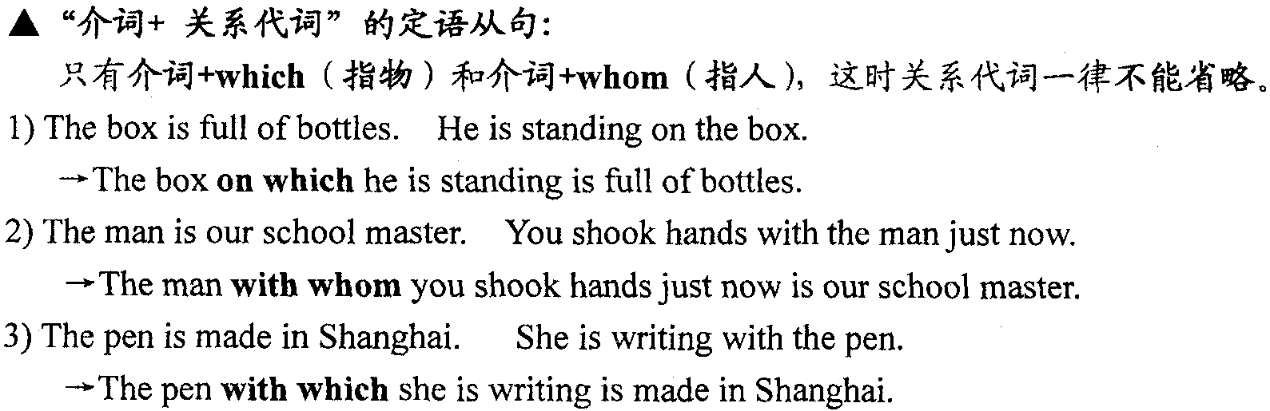

★ 定语从句中的主谓一致

1）关系代词在定语从句中作主语时，从句谓语动词的人称和数要和先行词保持一致。

1. one of ＋ 复数名词＋ 关系代词＋ 复数动词；
2. the only one of ＋ 复数名词＋ 关系代词＋ 单数动词

4)非限制性定语从句中，由关系代词as或which代替整个主句时，从句谓语动词要用第三人称单数。

五、as 引导非限制性定语从句与which 的区别

1、用于非限制性定语从句时，可以指代整个主句的内容，as 和which 可以换用。

2、as 引导非限制性定语从句，指代整个主句的内容，从句可置于句首，句中和句尾。

3、非限制性定语从句中谓语为被动时，常用as 作主语。as is said/ known/ announced/ reported/ mentioned/ expected/ disused等。As is known to all, Taiwan is part of China.

4、as引导非限制性定语从句，有“正如”的含义，因此，下列句式中多用as:

as (it)appears, as (it)seems, as (it)often happens, as (it)was pointed out / said / reported / announced, as (it)was said earlier, as I remember (it), as is well－known, as is known to all, as anybody can see, as has been said above, as we had expected Things are not always as they appear. 等。

5、which 引导非限制定语从句，如指代整个主句的内容，从句只能置于句尾。

The decision was postponed, which was exactly what he wanted.

6．which 引导非限制性定语从句，指代主句中的一个词（先行词）从句置于先行词后，可在句中或句尾。 The football match, which I watched yesterday, is very interesting.

7、which 引导非限制性定语从句，指代整个主句的内容，从句的谓语带有宾语，有的还带宾语补足语。

After that things improved, which astonished me.

Water changes into steam, which is known to be a physical change.

8、which 引导非限制性定语从句，指代整个主句的内容，从句意思可与主句相反，即从句为否定式或带否定前缀的形容词。

He can write a letter in English, which I cannot.

He was married again, which was unexpected.

★ as的考点总结：①. as可以作为关系代词引导限定性定语从句。例如：限定性定语从句（常用于such/so…as 和the same…as等句式中 ） “the same …as”. “such/so…as”中的as 可以指人或物, 作从句的主语、宾语、表语或介词的宾语。 ②. 引导非限制性定语从句（as可以作为关系代词引导非限制性定语从句时，as指代整个主句：也就是说，将整个主句看成一件事或是一个事实；并对其进行补充说明。这种非限制性定语从句既可以放在主句之前，也可以放在主句之后。）

**第二部分 习题专练**

1. The last place ______ we visited in the country was a farm.

A. where B. which C. that D. as

2. This is the very book ______ I’m looking for.

A. that B. what C. which D. one

3. We’re talking about the piano and the pianist ______ were in the concert we attended last night.

A. which B. whom C. who D. that

4. All the neighbors admire the family ______ the parents are treating their child like a friend.

A. why B. where C. which D. that

5. We are living in an age ______ many things are done on computer.

A. which B. that C. whose D. when

6. Winter is the time of year ______ the days are short and nights are long.

A. that     B. which      C. when      D. whose

7. I’ll give you my friend’s home address, ______ I can be reached most evenings.

A. which B. when C. whom D. where

8. The hours ______ the children spend in their one-way relationship with television people undoubtedly affected their relationship with real-life people.

A. that B. when C. in which D. on which

9. Earth is a rocky planet ______ liquid water, which is necessary for life, can exist.

A. as B. which C. where D. when

10. We must learn to deal with the condition ______ there is neither weight nor gravity, neither up nor down.

A. which B. by which C. that D. where

11. These old pictures bring to their mind the college days ______ they spent together, ______ life was hard but happy.

A. which; when B. when; which C. which; which D. when; when

12. The wolves hid themselves in the places ______ couldn’t be found.

A. that B. where C. in which D. in that

13. The house ______ the capitalist(资本家) used to live in is now a nursery.

A. that B. where C. what D. when

14. The days are gone ______ we used “foreign oil”.

A. that B. when C. which D. what

15. Can you think out a situation ______ this idiom can be used?

A. in which B. that C. for which D. when

16. No one can write a dictionary ______ everything is included.

A. that B. where C. in where D. to which

17. He makes good use of the time ______ he can spare when he is not at work.

A. when B. which C. in that D. in which

18. Many people who had seen the film were afraid to go to the forest when they remembered the scenes ______ people were eaten by the tigers.

A. in which B. by which C. which D. that

19. Zhang Yimou, ______ life was once very hard, is one of the greatest directors in the world.

A. in which      B. for whom      C. for whose     D. in whom

20. The freezing point is the temperature ______ water changes into ice.

A. at which B. on that C. in which D. of what

21. The train ______ she was travelling was late.

A. which B. where C. on which D. in that

22. He is the English teacher ______ help we have made great progress.

A. under whose B. with whom C. whose D. with whose

23. —— How about the games?

—— Very interesting, and the ones ______ the young men competed were really exciting.

A. what B. for whom C. where D. on which

24. This is one of the means ______ the electric energy is conducted from one place to another.

A. by which B. in which C. through which D. with which

25. This is the house the window ______ faces south.

A. of which B. which C. of it D. whose

26. That tree, ______ branches are almost bare, is very old.

A. whose B. of which C. in which D. on which

27. After the adjustment of financial policies, many netizens put up posts, 90 percent ______ carried the message of approval.

A. of which B. of whom C. of them D. of what

28. In our factory there are 2,000 workers, two thirds of ______ are women.

A. them B. which C. whom D. who

29. There are two thousand students in our school, ______ are girls.

A. two-thirds in which B. two-thirds in them C. two-thirds of them D. of whom two-thirds

30. She has three CDs，but none of ______ is interesting.

A. what B. which C. that D. them

31. —— How do you like the book?

—— It’s quite different from ______ I read last month.

A. that B. which C. the one D. the one what

32. The great day we looked forward to ______ at last.

A. come B. came C. coming D. comes

33. The doctor did all ______ to save the wounded boy.

A. what he could B. he could C. which he could D. could do

34. —— The electrical fan she ______ in town yesterday works well again.

—— Thanks to the repairman, it does work well again.

A. repaired B. had repaired C. has repaired D. had had repaired

35. I’ll tell you ______ he told me last week.

A. all which B. that C. all that D. which

36. The astronaut did many experiments in the spaceship, ______ much help for knowing space.

A. which we think it is B. which we think are of

C. of which we think is D. I think which is of

37. He is the man ______ you think is qualified for the job.

A. whom B. who C. whose D. of whom

38. It’s the third time ______ late this month.

A. that you arrived B. when you arrived C. that you’ve arrived D. when you’ve arrived

39 Is it in that factory ______ “Red Flag” cars are produced?

A. in which B. where C. which D. that

40. Jack, as well as his friends who ______ fond of football games, ______ traveled with the team.

A. is; has B. are; have C. are; has D. is; have

41. I, ______ your good friend, will try my best to help you out.

A. who is B. who am C. that is D. what is

42. He is the only one of the three ______ got the new idea.

A. who have　 　 B. whom have 　 C. who has　 D. whose has

43. These students will graduate from the university next summer, ____ they will have studied here for four years.

A. by then B. by that time C. by what time D. by which time

44. He was educated at the local high school, ______ he went on to Beijing University.

A. after which B. after that C. in which D. in that

45. I want to use the same dictionary ______ was used yesterday.

A. which B. who C. what D. as

46. I have bought such a watch ______ was advertised on TV.

A. that B. which C. as D. it

47. He has got himself into a dangerous situation ______ he is likely to lose control over the plane.

A. where B. which C. while D. when

48. Today, we’ll discuss a number of cases ______ beginners of English fail to use the language properly.

A. which B. as C. why D. where

49. Is this the reason she gave for not finishing her homework yesterday?

A. why B. for which C. that D. to which

50. The reason _____ he is late was ______ his mother was ill.

A. why; because B. why; that C. for; because D. for; that

**高三年级 英语寒假在线课堂**

**专题复习八 状语从句**

**一、知识梳理**

**状语从句：**由从句担任的状语，在句子中可修饰动词、形容词、副词或整个句子，可以用来表示时间、地点、原因、目的、结果、条件、方式、比较、让步等。

* 让步状语从句

让步状语从句引导词主要有__________________________________________________。

【Practice 1】

1. ________________________(仅管他是个孩子), he knows a lot. (though)

  = ___________________________, he knows a lot. (as)

2. ___________________________(无论你说什么), Ill never change my mind.

3. ______ the students came from different countries, they got along quite well in the summer camp.

A. While B. Unless C. Since D. Until

* 时间状语从句

时间的状语从句可由___________________________________________________等引导。

【Practice 2】

1. when while as

The teachers were having a meeting _______ I came into the office.

Mary made coffee _______ her guests were finishing their meal.

He hurried home, looking behind _____ he went.

2. 一... 就

_____________ had I gone to bed _______ I went to sleep. (一... 就...)

3. I have heard a lot of good things about you______ I came back from abroad.

A. since B. until C. before D. when

If you miss this chance, it may be years ______ you get another one.

A. as B. before C. since D. after

* 条件状语从句

 条件状语从句引导词主要有if, unless, so (as) long as, on condition that, proving that等。

【Practice 3】 You may borrow the book ______ _______ _______ you keep it clean. (只要)

* 原因状语从句

 原因状语从句表示原因，常用连词是__________________________________________等。

 【Practice 4】 He is disappointed, ______________________________. (因为他没能得到工作。)

* 地点状语从句

引导地点状语从句的连词是___________________。

【Practice 5】1.Sit_________________________________________. (你想坐的地方)

       2. Make a mark ________________________________. (在你有问题的地方)

3. ________________________________, there’s a way.

* 目的状语从句

目的状语从句常用的引导词是______________________________________________。 【Practice 6】

 1. He left early ______ ______ he should miss the train. （以防）

2.She has bought the book ______ _______ ______ she could follow the TV lessons. (为了)

* 结果状语从句

结果状语表示事情结果, 常用_____________________等引导。

【Practice 7】 Jack is ____ honest a worker ______ we all believe in him.

=Jack is ____ an honest worker ______ we all believe in him.

= Jack is ____ an honest worker ______ we all believe in.

* 其他状语从句 （方式状语从句、比较状语从句）

【Practice 8】

1.You must do the exercise _____ I show you. (按照)

      2. He acted ______ ______ nothing had happened. （似乎）

3. ______a single word can change the meaning of a sentence, a single sentence can change the meaning of a paragraph.

A. Just as B. Even though C. Until D. Unless

4. EQ is ______ important, if not more important than IQ.

A. so B. very C. even D. as

**二、即学即练 --用合适的连词填空**

while, since, though, unless, where, however, as, so...that..., as long as, until

1. Frank insisted that he was not asleep _______ I had great difficulty in waking him up.

2. Try _____ she might, Susan couldn't get the door open.

3. I have been teaching here _______ I left college.

4. We will begin _____ we stopped yesterday so that no point will be left out.

5. _________ dry a desert may be, it is not necessarily lifeless.

6. The little boy won't go to sleep ______ his mother tells him a story.

7. Jack is _____ honest a worker _______ we all believe him.

8. I will wait ________ the book comes out.

9. _______ you work hard, you will succeed.

10. ________ the students came from different countries, they get along well.

**三、巩固练习**

1. My grandfather still plays tennis now and then, ________ he’s in his nineties.

A. as long as B. as if C. even though D. in case

2. ______ the average age of the population increases, there are more and more old people to care for.

A. Unless B. Until C. As D. While

3. _______online shopping has changed our life , not all of its effects have been positive.

A. Since B. After C. While D. Unless

4. The girl had hardly rung the bell ______ the door was opened suddenly, and her friend rushed out to greet her .

A. when B. until C. as D. since

5. ______ China’s reform and opening up in late 1978, its quick development has aroused worldwide attention.

A. When B. As C. While D. Since

6. The key is that, ______ full your schedule is, only when you try really hard ______ always fit some more things in it.

A. no matter how; can you B. no matter what; can you

C. however; you can D. whatever; can you

7. Problems arise ______ caution is absent.

A. where B. in which C. that D. what

8. —Is it a good idea to buy him the toy that he's longing for?

—Better not. ______ you have bought him everything he wants, he won't behave himself.

A. If B. As if C. Even if D. As though

9. _____the damage is done, it will take many years for the farmland to recover.

A. Until B. Unless C. Once D. Although

10. ______ it is true that a student's most important goal is to do well in his or her study, it doesn't need to be the only goal.

A. While B. When C. As D. Before

11. If you miss this chance, it may be years ____ you get another one.

A. as B. before C. since D. after

12. It is so cold that you can’t go outside _____ fully covered in thick clothes.

A. if B. unless C. once D. when

13. ______ he once felt like giving up, he now has the determination to push further and keep on going.

A. Where B. As C. In case D. Now that

14. I'll be out for some time. ______ anything important happens, call me up immediately.

A. In case             B. As if                C. Even though       D. Now that

15. Mark needs to learn Chinese______　his company is opening a branch in Beijing.

1. unless B. until C. although D. since

16. How could I lie to her ________ she lived for the truth, whether it was found in music or people?

1. unless B. when C. while D. though

17 . Alcohol can damage the liver and do great harm if ______ in large numbers.

A. being consumed B. consumed

C. to consume D. consuming

18. China will remain a developing country, as there is still a long way to go ________ we’ll be able to achieve modernization.

A. before B. since C. after D. during

19. We should protect our environment from being polluted ________ our next generation will enjoy a blue sky and live a healthy life.

A. as if B. so that C. even if D. in case

20. However difficult it seems to be，you will make it ________ you put your heart into it.

A. so that B. as though C. as long as D. in that

21. —I sometimes call my son abroad，but it's expensive.

—Why do you waste money ________ you could easily use QQ？

A. while B. unless C. until D. when

22. The young man left in a hurry ______ I could say thanks to him.

A. when B. until C. before D. so

23. ______ you may have, you should gather your courage to face the challenge.

A. However a serious problem B. What a serious problem

C. However serious a problem D. What serious a problem

24. ______ you recognize an idiom when it is being used, it is easy to misunderstand what you read or hear spoken.

A. Although B. Because C. Unless D. While

25. Lessons can be learned to face the future, ______ history cannot be changed.

A. though B. as C. since D. unless

26. If anything should happen, the nearest person he could contact by radio, _____ there was a ship nearby, would be on an island 885 miles away.

A. until B. when C. once D. unless

27. ______, a small advertisement held my attention, which read “Easy job. Good wages. No experience necessary.”

1. Looking through the newspaper

B. While I was looking through the newspaper

C. To look through the newspaper

D. I was looking through the newspaper

28. ______, I have never seen anyone who's as capable as John.

A. As long as I have traveled B. Much as I have traveled

C. Now that I have traveled so much D. As I have traveled so much

29. _________ reading books is rewarding on the whole, not all books are necessarily good for children.

A. Since B. When C. Until D. While

30. This medicine is quite beneficial to your recovery after the operation,______ you take it as told.

A. unless B. providing C. considering D. since

高三年级 英语寒假在线课堂

专题复习九 虚拟语气及特殊句型

**I. 虚拟语气思维导图**

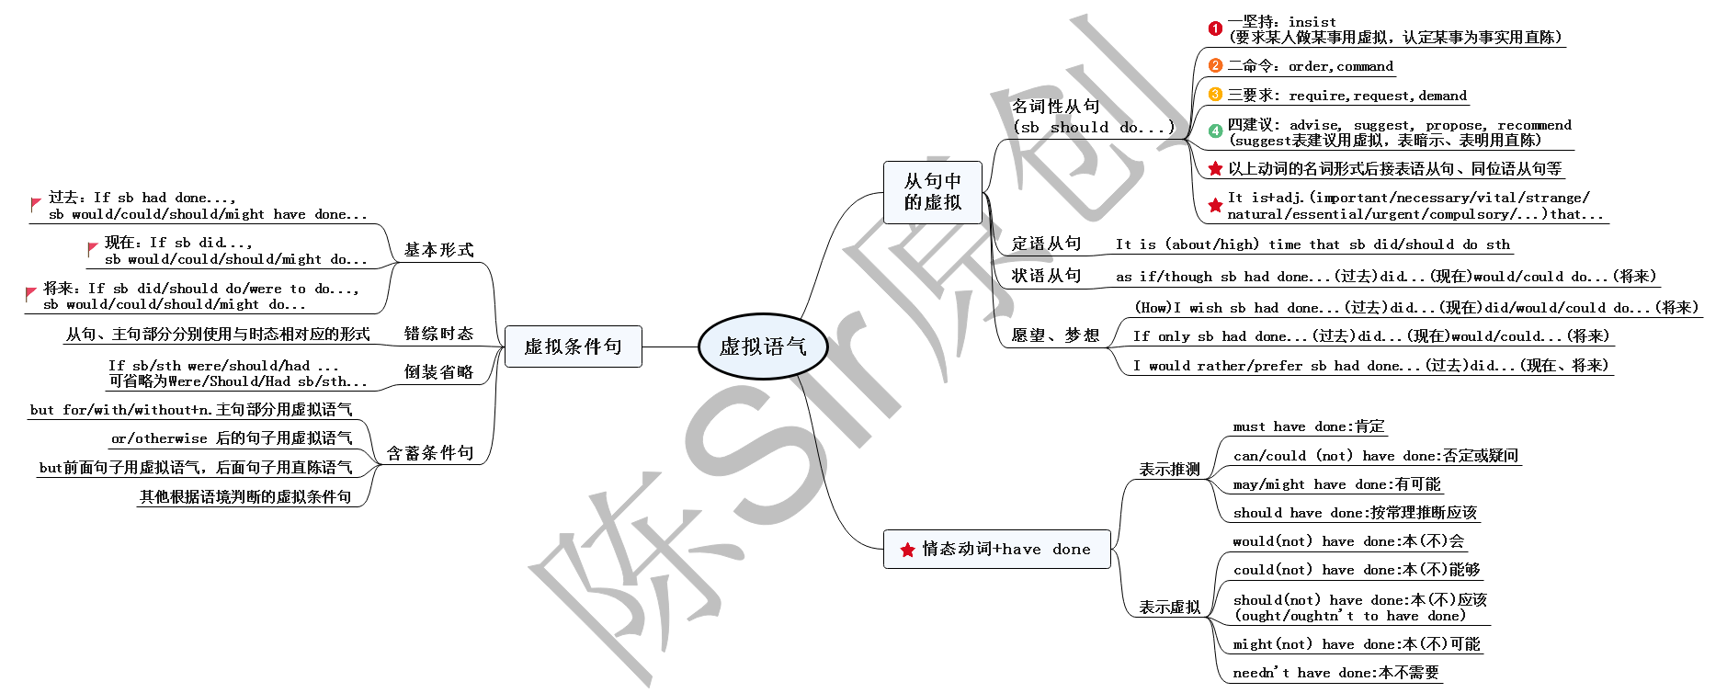

**II. 虚拟语气考点透视**

1. If she found the fact that the antique ______ a fake(赝品), I’m afraid she would be as mad as a wet hen.

A. is B. was C. will be D. had been

【陈Sir点拨】虚拟语气中一定是所有的谓语动词都虚拟吗？___________

2. What a pity! If I had caught that flight, I ______ over the Pacific Ocean now.

A. would fly B. would have flown C. would be flying D. were flying

【陈Sir点拨】错综时态虚拟语气，一定要紧紧抓住时间状语。

3. ______ no modern telecommunications, we would have to wait for weeks to get news from around the world.

A. Were there B. Had there been C. If there are D. If there have been

【陈Sir点拨】虚拟条件句中可以置于句首、省略if的是哪三个词？______________________

4. --- Did you hear Tom was criticized for his spelling mistakes in his English compositions?

--- Yes, but a more careful person ______ so many mistakes.

A. wouldn’t make B. needn’t have made C. shouldn’t make D. wouldn’t have made

【陈Sir点拨】这一题真的好含蓄。

5. Who ______ the survey about the environmental pollution in this area?

A. you suggest he have finish B. you suggest he has to finish

C. do you suggest he have finish D. do you suggest he has finish

【陈Sir点拨】这道题我们需要考虑哪几个因素？_________________________________

6. When a pencil is partly in a glass of water, it looks as if it ______.

A. breaks B. has broken C. were broken D. had been broken

【陈Sir点拨】眼见未必为实啊！

7. If only ___________________________________________. (但愿世界上没有战争，暴力和贫困。)

【陈Sir点拨】only if是什么意思？_________________

8. --- You could hardly imagine what great trouble John had reserving a hotel room during the G20 summit.

--- He ______ in my apartment. It was vacant as I was abroad then.

A. must have stayed B. should have stayed C. could have stayed D. would have stayed

【陈Sir点拨】 “情态动词+have done” 有哪两种用法？ ______________________

**III. 倒装句思维导图**

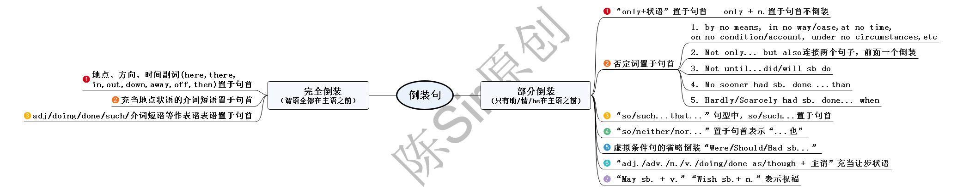

**IV. 倒装句考点透视**

1. Near the table ______ a poor dog, which desired to satisfy his hunger with ______ fell from the table.

A. laid; something B. laid; that C. lay; that D. lay; what

【陈Sir点拨】这种句型中的常见谓语动词有哪些？______________________

2. __________________________（这就是Einstein）, a simple man with great achievements.

【陈Sir点拨】逗号后是同位语。

3. It’s believed that _____________________ （我们只有合作） will our companies develop more smoothly.

【陈Sir点拨】书面表达最常用句型之一。

4. We are told under no circumstances ______ the telephone in the office for personal affairs.

A. we could use B. we may use C. did we use D. may we use

5. 他不仅歌唱得好且舞跳得好。

Not only ________________________, but _________________________.

【陈Sir点拨】两个句子，哪个倒装？___________

6. 直到她摘下墨镜我才认出了她

Not until ______________________ her dark glasses _______________________ her.

It was not until ____________________ her dark glasses ____________________ her.

【陈Sir点拨】这两个句型很容易张冠李戴。

7. ______ that I couldn’t be absorbed in the work.

A. They made such much noise B. So loudly they talked

C. It was so noise outside D. Such a loud noise did they make

【陈Sir点拨】注意so和such的用法。

8. If you don’t attend the conference tomorrow, neither/nor _______________. (我也不)

【陈Sir点拨】这里的时态应用了什么原则？__________________

9. Although/Though he was a child, he behaved well at the party.

__________________________, he behaved well at the party.

**V. 强调句型**

1. 基本形式：_______________________________________________________________

*not until的强调句型_____________________________________________________

2. 一般疑问句：_____________________________________________________________

3. 特殊疑问句：_____________________________________________________________

*疑问句的强调句型在复合句中做宾语时，要注意使用__________________

**巩固训练**

1. He hesitated for a moment before kicking the ball, otherwise he ______ a goal.

A. had scored B. scored C. would score D. would have scored

2. Without electricity human life ______ quite different today.

A. is B. will be C. would have been D. would be

3. On AIDS Day, the minister of Health Department demanded that the problems ______ paid special attention to.

A. referred to being B. referred to be C. refer to being D. refer to be

4. Some demands were made at the meeting, including one that the government ______ the rising housing prices.

A. control B. would control C. controlled D. may control

5. — You didn’t wait for Mr. Black last night, did you?

— Yes, but we______. He didn’t return home at all.

A. needn’t have B couldn’t have C. didn’t need to D. should have

6. — Was Sun Yang sorry for his driving without a license?

— Yeah, he said he ______ a role model as a public figure but he failed to.

A. was B. had been C. should have been D. would be

7. — Did you go to Taylor Swift’s concert last night?

— I would rather I ______. But I was preparing a report for my boss.

A. did B. had C. would D. might

8. There is a real possibility that these animals could be frightened, ______ a sudden loud noise.

A. should be there B. should there be C. there were to be D. there should be

9. — Why didn’t you stop Mary cheating in the final exam?

— But what ______ otherwise? She just sticks with Alex and turns a deaf ear to my advice.

A. could do B. may I have done

C. should I have done D. could I have done

10. — Thank you so much for saving my son and bringing him home.

— Don’t mention it. I only did what anyone else ______ in my place.

A. must do B. should do C. may have done D. would have done

11. ______ today, he would get there by Friday.

A. Would he leave B. Was he leaving C. Were he to leave D. If he leaves

12. The law requires that everyone ______ his car checked at least once a year.

A. has B. had C. have D. will have

13. I wish that you ______ such a bad headache because I’m sure that you would have enjoyed the concert.

A. hadn’t B. didn’t have had C. hadn’t had D. hadn’t have

14. Jane’s pale face suggested that she ______ ill and her parents suggested that she ______ medicine.

A. be; should take   B. was; take   C. was; takes    D. be; took

15. It's astonishing that she ______ sad at the news that has nothing to do with her.

A. felt B. should feel C. will feel D. would feel

16. Despite the fact that his scores were good, they were not as excellent as a student with his intelligence ________.

A. should have achieved B. had achieved C. would achieve D. achieved

17. Mr. Brown is going to make a speech on grammar, but I’d rather he ______ on writing skills.

A. would focus B. was going to focus C. will focus D. focused

18. — I can’t think why he ______ so angry. I meant no offence.

— It’s typical of him to be sensitive.

A. should have been B. must have been C. might have been D. can have been

19. — Is everyone here?

— Not yet. Look, there ______ the rest of our guests.

A. come B. comes C. is coming D. are coming

20. It was not until ______ to prepare his lessons.

A. did his father come in that the boy began B. did his father come in did the boy begin

C. his father came in that the boy began D. his father came in did the boy begin

21. — Did you hear that Li Hua was robbed during his recent trip to South Africa?

— Yes, not only ______ his money, but he was nearly killed.

A. he lost B. did he lose C. he had lost D. was he lost

22. — How much do you know about the 3D film technology?

— A little. Not until ______ the hot movie Avatar ______ some about it.

A. did I see; did I begin to learn B. I saw; I began to learn

C. I saw; did I begin to learn D. did I see; I began to learn

23. — Oh, poor Peter looks very weak.

— ______ if you suffer from high fever for three days on end.

A. So are you B. So you are C. So will you D. So you will

24. Difficult as rumors on micro blog are ______, the authorities will step up supervision so that people will not be easily misled.

A. to prevent B. preventing C. to be prevented D. being prevented

25. ______ homework did we have to do that we had no time to take a rest.

A. So much B. Too much C. Too little D. So little

26. Was it not until ______ that they began to push for other ones?

A. people had been run out of natural resources B. had people run out of natural resources

C. did people run out of natural resources D. people had run out of natural resources

27. It was the promise ______ he would give Lucy all ______ he had, including his life, ______ pushed him to save Darney.

A. that; that; that B. that; what; which C. which; that; which D. which; that; that

高三年级 英语寒假在线课堂

专题复习十 完型填空

（一）

请认真阅读下面短文，从短文后各题所给的A、B、C、D四个选项中，选出最佳选项。

We must think anew --- and act anew. —— Abraham Lincoln

When Abraham Lincoln wrote these words, he was facing the greatest crisis: the Civil War. He knew that 1 measures were not enough. “The dogmas (教条) of the 2 past,” he wrote, “are inadequate to the stormy present. We must think anew, and act anew.”

New thought, new action --- how simple it sounds but how 3 it is! Most of us tend to be __4 _ by old habits of thought. When crisis threatens, it is all too easy to react as we did before.

But great 5 awaits men and women who can change the pattern of their thinking to meet new challenges. I have 6 of this in my own experience. When I first left college, I had no  7 of becoming a psychiatrist（精神病医生）. I taught drama in university. But two years later, 8 my life, I decided that, much 9 I enjoyed teaching, what I really wanted to be was a doctor.

The 10 to “act anew” was not easy. I knew I could hardly hope to become a(n) 11__ psychiatrist before I was forty. My friends advised strongly against such an extreme step. I took it 12 . I have never regretted it.

Today, many of the people who come to me for help are suffering from a kind of 13__ caused by blindly sticking to old patterns of thinking and acting. They can’t adapt to 14___ conditions. They find it so difficult to 15 that sometimes they break.

Quite often, in my 16 to help such people, I quote these words of Lincoln. When problems annoy us, I tell them --- when there is 17 no solution --- we must not act rigidly. We must not 18 our difficulties from old, habitual points of view. We must think anew, and with it will come the 19 and the confidence to act anew.

A great American told us this. We should remember his words and try to live 20 them.

1. A. immediate B. ordinary C. effective D. temporary

2. A. quiet B. dark C. glorious D. recent

3. A. impossible B. difficult C. exciting D. interesting

4. A. attracted B. covered C. ignored D. restricted

5. A. reward B. promotion C. responsibility D. trouble

6. A. notice B. enough C. proof D. memory

7. A. sense B. chance C. knowledge D. intention

8. A. enjoying B. reviewing C. spending D. restarting

9. A. as B. since C. for D. unless

10. A. promise B. chance C. desire D. decision

11. A. little-known B. privileged C. established D. ambitious

12. A. moreover B. anyway C. instead D. therefore

13. A. rigidity B. foolishness C. sickness D. gravity

14. A. pressing B. existing C. changing D. appealing

15. A. insist B. pass C. bend D. flee

16. A. beliefs B. requests C. wishes D. efforts

17. A. seemingly B. surprisingly C. partly D. originally

18. A. take on B. look at C. deal with D. see to

19. A. interest B. reason C. passion D. power

20. A. in B. by C. on D. for

（二）

请认真阅读下面短文，从短文后各题所给的A、B、C、D四个选项中，选出最佳选项。

In modern society loneliness can be seen as a social phenomenon and people can experience loneliness for many reasons. It is a very common, 21 normally temporary, consequence of a breakup, divorce, or loss of any important 22 relationship. In these cases, loneliness may 23 both from the loss of a specific person or from 24 of social circles. The loss of a significant person in one's life will 25 lead to a grief response; in this situation, one might feel lonely, even while in the 26 of others.

There are many different ways used to treat loneliness. The first step that most doctors __27 to patients is treatment. Short term treatment typically 28 over a period of ten to twenty weeks. During treatment, emphasis is put 29 understanding the cause of the problem, thoroughly changing the 30 thoughts, feelings, and attitudes resulting from the problem, and exploring ways to help the patient feel 31 . Some doctors also recommend group treatment a means to connect with other sufferers and establish a support system.   
 32 treatment is animal-assisted treatment. Studies and surveys indicate that the __33 of animal companions such as dogs, cats, rabbits, and guinea pigs can _34__ feelings of loneliness or depression among some sufferers. 35 the companionship the animal itself provides there may also be increased opportunities for 36 with other pet owners. Results of a study also suggest that 37 improper social cognition (认知) offers the best chance of reducing loneliness.

38 , loneliness can sometimes play an important role in the creative process. In some people, temporary or prolonged loneliness can lead to remarkable artistic and creative expression, for example, as was the _ 39 with poet Emily Dickinson, and many musicians. This is not to imply that loneliness itself ensures this creativity, 40 , it may have an influence on the subject matter of the artist and more likely be present in individuals engaged in creative activities.

21. A. however B. or C. but D. though

22. A. short-term B. long-term C. abstract D. concrete

23. A. break B. suffer C. result D. benefit

24. A. turning out B. dropping out C. falling out D. putting out

25. A. occasionally B. intentionally C. typically D. casually

26. A. charge B. company C. face D. absence

27. A. commit B. submit C. recommend D. resign

28. A. hits B. occurs C. strikes D. turns

29. A. in B. to C. for D. on

30. A. negative B. explicit C. positive D. original

31. A. affected B. touched C. disconnected D. connected

32. A. one B. other C. another D. the other

33. A. presence B. switch C. control D. management

34. A. speed B. save C. ease 　 D. solve

35. A. beyond B. except C. without D. with

36. A. wrestling B. training C. popularizing D. socializing

37. A. calculating B. correcting C. assessing D. transmitting

38. A. however B. but C. therefore D. though

39. A. turn B. case C. way D. return

40. A. yet B. still C. just D. rather

（三）

请认真阅读下面短文，从短文后各题所给的A、B、C、D四个选项中，选出最佳选项。

Do you know how discipline can help you achieve your goals? Do you know that discipline is important to 41 ? What is the power of discipline? How to become disciplined?

You might think that many people are not self disciplined, 42 I’m going to prove to you that people in general are disciplined, but 43 , in non-beneficial ways. There are many people who smoke daily 44 the fact that it is harmful and 45 and it could kill them. Such people are disciplined at 46 cigarettes and smoking. There are people who are disciplined at drinking lots of alcohol daily. Such people are disciplined at consuming alcohol. Do you 47 where I am going with this?

One of my friends who has a 48 for running spends half an hour every single morning running. Whether it is snowing or raining, she has to run. This is the kind of 49 discipline that you are supposed to 50 and create in your life.

Do you know someone who bought a book, but didn’t finish 51 it for some reason? Do you know someone who decided to improve his 52 and start eating more vegetables and fruit, but after two weeks, he 53 ?

These are all examples of 54 of discipline. If you are not disciplined, then you will have a hard time to get your 55 . As I mentioned in my book “The ultimate guide to achieving your goals” that you could know what you want, 56 , and take action, but if you are not self-disciplined, you will 57 give up.

With discipline, you can start getting up early in the morning, exercise, and 58 yourself  
of the non-beneficial habits such as smoking and eating non-healthy food. With discipline, you can change negative habits to positive habits. With discipline, you can join the gym and start working on having a 59 body. Do you see what the 60 of discipline can do?

Always remember what Jim Rohn said, “One discipline always leads to another discipline.”

41. A. wealth B. success C. fortune D. health

42. A. for B. and C. or D. but

43. A. unfortunately B. unwillingly C. unnecessarily D. unexpectedly

44. A. besides B. despite C. except D. without

45. A. courageous B. disgusting C. dangerous D. forbidden

46. A. selling B. buying C. getting D. consuming

47. A. care B. see C. feel D. mind

48. A. passion B. gift C. respect D. reason

49. A. formal B. positive C. negative D. religious

50. A. form B. learn C. follow D. believe

51. A. reading B. reciting C. analyzing D. reviewing

52. A. service B. diet C. skill D. performance

53. A. broke down B. turned up C. gave up D. set out

54. A. lack B. gesture C. sign D. symbol

55. A. attention B. order C. credit D. desire

56. A. plan B. listen C. ask D. hope

57. A. obviously B. practically C. likely D. quickly

58. A. persuade B. inform C. deliver D. break

59. A. healthier B. weaker C. heavier D. clumsier

60. A. demand B. power C. principle D. measure

**高三年级 英语寒假在线课堂**

**专题复习十一 阅读理解（议论文）**

**高考议论文常见命题点**

**一、作者的观点**

**二、阐述观点所运用的手法**

**三、作者的写作目的（作者的态度、观点等）**

**高考议论文精讲（2013年江苏卷B篇）**

We’ve considered several ways of paying to cut inline: hiring line standers, buying tickets from scalpers (票贩子), or purchasing line cutting privileges directly from, say, an airline or an amusement park. Each of these deals replaces the morals of the queue (waiting your turn) with the morals of the market (paying a price for faster service).

Markets and queues—paying and waiting—are two different ways of allocating things, and each is appropriate to different activities. The morals of the queue, “First come, first served,” have an egalitarian(平等主义的) appeal. They tell us to ignore privilege, power, and deep pockets.

The principle seems right on play grounds and at bus stops. But the morals of the queue do not govern all occasions. If I put my house up for sale, I have no duty to accept the first offer that comes along, simply because it’s the first. Selling my house and waiting for a bus are different activities, properly governed by different standards.

Sometimes standards change, and it is unclear which principle should apply. Think of the recorded message you hear, played over and over, as you wait on hold when calling your bank: “Your call will be answered in the order in which it was received.” This is essential for the morals of the queue. It’s as if the company is trying to ease our impatience with fairness.

But don’t take the recorded message too seriously. Today, some people’s calls are answered faster than others. Call center technology enables companies to “score” incoming call sand to give faster service to those that come from rich places. You might call this telephonic queue jumping.

Of course, markets and queues are not the only ways of allocating things. Some goods we distribute by merit, others by need, still others by chance. However, the tendency of markets to replace queues, and other non-market ways of allocating goods is so common in modern life that we scarcely notice it anymore. It is striking that most of the paid queue-jumping schemes we’ve considered—at airports and amusement parks, in call centers, doctors’ offices, and national parks—are recent developments, scarcely imaginable three decades ago. The disappearance of the queues in these places may seem an unusual concern, but these are not the only places that markets have entered.

**1. According to the author, which of the following seems governed by the principle “First**

**come, first served”?**

**A. Taking buses.**  B. Buying houses.

C. Flying with an airline. D. Visiting amusement parks.

**2. The example of the recorded message in Paragraphs 4 and 5 illustrates________.**

A. the necessity of patience in queuing B. the advantage of modern technology

**C. the uncertainty of allocation principle** D. the fairness of telephonic services

**3. The passage is meant to____________.**

A. justify paying for faster services **B. discuss the morals of allocating things**

C. analyze the reason for standing in line D. criticize the behavior of queue jumping

**议论文命题剖析及解题技巧**

**一、作者的观点、论点**

**（一）**

It is remarkable that an expression from a long-dead language generates more than 25million online search results. Yet just as striking is the fact that there is not one carpe diem, but many. While usually translated as “seize” the day, the original Latin is sometimes interpreted as “harvest”, or “enjoy” the day. These variations tell us that carpe diem means different things to different people. For some it’s about taking a once in a lifetime opportunity, while for others it is about living calmly in the present moment. We might casually use the term carpe diem when chatting with a friend, **but** how many of us are aware of its many personalities hidden beneath the surface?

**1. What does the author intend to tell us about carpe diem ?**

A. People often create different situations for carpe diem.

B. Carpe diem should be better interpreted than before.

C. People usually scratch the surface of carpe diem.

D. Carpe diem should be replaced with new terms.

**二、支持观点、论点的论据、事例、引语**

**（一）**

Research that examines the differences between meaning and happiness finds that the things that give us a sense of meaning don’t necessarily make us happy. Moreover, **people who report having meaningful lives are often more interested in doing things for others**, while those who focus mostly on doing things for themselves report being only superficially (表面的) happy. The essential quality of “meaning” has to do with having a sense of being involved in something bigger than the self.

**We all know people obtain a great sense of meaning even in the most unpleasant of circumstances.** Many **volunteers** spend portions of their lives working indangerous, war-torn areas trying to keep disease and death from innocent civilians or teaching orphans to read. Their pain is real; their sense of doing something truly meaningful is substantial (丰富的). They show how our deep-rooted desire to believe that our lives have purpose beyond our lifespan drives us to work extra hard, even to the point of our own personal suffering, in order to gain more meaning.

**1. According to the research, which of the practices gives us a sense of meaning?**

A. Reading a classic novel in the leisure time.

B. Enjoying sunshine and comfort on the beach.

C. Accompanying terminal patients in hospital.

D. Listening to popular music in the sitting room.

**2. The example of people’s voluntary work in Para. 4 mainly indicates that ______.**

A. experiencing personal suffering is a necessary part of our growth

B. voluntary work serves the purpose of adding happiness to our lives

C. it’s our duty to help people in need to get out of their sufferings

D. life’s great rewards come from our experience of tough circumstances

**（二）**

Two psychologists, Karalyn Enz and Jennifer Talarico, throw light on these matters in a new study with a title that nods to Frost: Forks In The Road. They sought to clarify how people think about “turning points” versus “transitions” in life. A turning point, by their definition, is a moment that changes your future – deciding to leave a job or marriage, say – but often isn’t visible from the outside, at least at first. “Transitions” involve big external changes: going to university, marrying, emigrating (迁出). Sometimes the two go together, as when you move to a new place and realize it’s where you belong. (“New Yorkers are born all over the country,” Delia Ephron said, “and then they come to New York and it hits them: oh, that’s who I am.”) But it’s turning points we remember as most significant, Enz and Talarico conclude, whether or not they also involve transitions.

**1. Which of the following can be considered as a transition?**

A. Your experience of midlife crisis.

B. Your choice of the road to take.

C. Your decision to travel abroad.

D. Your move into a new flat.

**三、写作手法**

**（一）**

However, at the back of the minds of many people, especially those who the “good old days”, efficiency comes with a price. When communication becomes efficient, people are able to conduct one another no matter where they are and at whatever time they wish to. The click of a button allows people miles apart to talk or to see each other without even leaving their homes. With the communication gadgets, such as mobile phones and ipads, people often do not take the effect to visit one another personally. A personal visit carries with the additional feature of having to be in the person’s presence for as long as the visit lasts. We cannot unnecessarily excuse our selves or turn the other person off.

**1. The author explains “efficiency comes with a price” by _______.**

A. describing a process B. using examples

C. following time order D. making classification

**（二）**

In our age of distraction, grasping these different meanings is more important than ever. They are an antidote（解毒药）to the reality that we are, as Shakespeare put it, “food for worms”. Life is short and our time is running out.

But here’s the problem: carpe diem has been hijacked（绑架）. Who, or what, are the hijackers? First, the spirit of “seize the day” has been secretly hijacked by consumer culture, which has recast it as Black Friday shopping sprees and one-click buying: Just Do It has come to mean Just Buy It.

Alongside this is the growing cult of efficiency and time management that has driven us towards hyper-scheduled living, turning the spontaneity of Just Do It into a culture of Just Plan It.

A third hijacker is 24/7 digital entertainment that is replacing vibrant life experiences with vicarious, screen-based pleasures. Rather than Just Do It, we increasingly Just Watch It instead.

Finally – and though it might seem counter-intuitive (直觉到的)– carpe diem has been hijacked by the mindfulness movement. While mindfulness has many proven benefits, from reducing stress to helping with depression, one of its unintended consequences has been to encourage the narrow idea that seizing the day is primarily about living in the here and now. Just Do It has become Just Breathe.

**1. The author presented the four hijackers by ________.**

A. making comparisons B. making classifications

C. analyzing causes D. following space order

**四、作者的写作目的与意图**

**（一）**

Confronted by these four hijackers, the art of seizing the day is disappearing and we urgently need to do something about it, or else risk losing touch with the carpe diem wisdom of humanity that has accumulated over the past two thousand years.

**1.** **What is the author’s purpose in writing this passage?**

A. To advocate us to return to the original meaning of carpe diem

B. To clarify some misunderstandings about carpe diem

C. To explain some historical facts about the change of carpe diem

D. To compare different people’s interpretation of carpe diem

**五、作者的态度、观点**

**（一）**

One of the ill effects of the spread of more intelligent computer networks is, at the same time, the spread of what might be called artificial stupidity. If AI is employed largely to replace unskilled labour, it is most productive when labour is kept unskilled or redefined that way. So much of the work in service industries is now simplified until it might be automated (自动化). And robots will never need pensions. AI is slowly reducing skilled work, like some forms of medical diagnosis (诊断), at the same time, as older doctors complain that the traditional human skills of diagnosis are falling out of medical training. The belief that everything worthwhile can be measured and then managed is far more damaging to humanity than the threat of artificial intelligence on its own.

But no victory in complicated Go games can bring us closer to truly human-like computers.

**1. What is the author’s attitude towards the future of artificial intelligence?**

学科网(www.zxxk.com)--教育资源门户，提供试卷、教案、课件、论文、素材及各类教学资源下载，还有大量而丰富的教学相关资讯！ A. Optimistic. B. Supportive. C. Sceptical. D. Cautious.

**（二）**

Behind every compulsion is the need to avoid what causes you pain or anxiety. Compulsive behaviour is not necessarily a mental disorder. Some forms of it can be, and people in its control deserve to be diagnosed and helped. But many are expressions of psychological needs we all feel: to be at peace and in control, to feel connected and to matter. And if those are mental illnesses, we’re all crazy.

**1. What’s the author’s attitude towards compulsion?**

A. Objective. B. Negative. C. Doubtful. D. Cautious.

**高三年级 英语寒假在线课堂**

**专题复习十二 阅读理解(说明文)**

**A**

In a unique research cooperation between Stratasys' Education, R&D departments and MIT's Self－Assembly Lab, a new process is being developed, known as 4D Printing.

The 4D printing concept, which allows materials to “self－assemble(自行组装)” into 3D structures, was initially proposed by Massachusetts Institute of Technology faculty member Skylar Tibbits. Tibbits and his team combined a strand(缕) of plastic with a layer made out of “smart” material that could self－assemble in water. They advanced this concept by creating materials that can change into several different complicated shapes, though this kind of material remains the bottleneck of 4D technology.

To many people that are just starting to get used to the idea of 3D printers, the name 4D is causing confusion because they cannot understand where this fourth “dimension” coming from. 4D technology shares many of the same principles of 3D printing and is essentially still about creating a new, 3D structure out of certain component; however, Tibbits states the fourth dimension at work here comes from concept of the fourth dimension of time. The difference between these 3D and 4D creations is that these new forms have the ability to transform and adapt over time.

4D printing works through self－assembly — a system where “disordered” elements form an “ordered” structure via an interaction. With these 4D printed materials, these disordered materials are strands or sheets of specially designed materials. Environmental changes then stimulate(刺激) a response from them so that they form a preprogrammed shape.

The idea of having adaptable technology that only relies on energy and non－human interactions raises some interesting questions about where 4D printing can be used and the practical applications in dangerous environments. This could mean improved infrastructures in extreme conditions, leading to a reduced need for workers to put themselves at risk, but the potential goes even further than that. The technology promises exciting new possibilities for a variety of applications. A solar panel or similar product could be produced in a flat shape onto which functional devices can be easily installed. It could then be changed to a compact shape for packing and shipping. After arriving at its destination, the product could be stimulated to form a different shape that serves its function. Also it could be used to build furniture, bikes, cars and even buildings. As with many of the ideas being put forward, it is easy to go a step too far into the extreme, but this just shows the potential of 4D in comparison to 3D.

The next stage for the research is to move from printing single strands to sheets and eventually whole structures. And water need not be the process's only energy source.

1. Which of the following displays the fourth dimension of 4D printing?

A. 4D printing creates a new, 3D structure out of certain component.

B. 4D technology reduces need for workers to put themselves at risk.

C. 4D technology can be used in many more fields than 3D printing.

D. 4D printed materials reshape themselves with conditions changing.

2. The major problem concerning the development of 4D printing lies in ______．

A. producing essential 4D printers　 B. creating proper smart materials

C. providing a suitable environment　 D. promoting practical applications

3. What does the passage lead you to believe?

A. 4D printing will take the place of 3D printing in the near future.

B. Most aspects of our daily life can be affected by 4D printing.

C. 4D printing will benefit humans by saving labor somehow.

D. Smart materials can be transformed into other types of material.

4. It can be inferred from the passage that ______．

A. electricity is not used in 4D technology B. 4D printing has been applied in industry

C. more potential of 4D is to be discovered D. smart materials can change in a random way

**B**

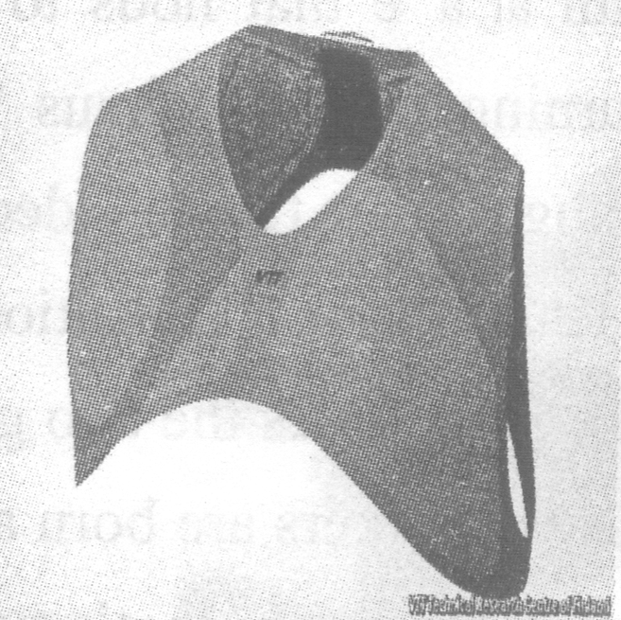The idea came to Ralph Liedert while he was sweating in the Californian sunshine, having been standing with his daughter for over an hour in a queue for a ride at Disneyland. What, he thought, if his T－shirt had a cooling system he could turn on, at the tap of a smart phone app, when he needed it. Luckily, Mr Liedert does have the means to make the dream reality, for he works at the VTT Technical Research Centre of Finland, as one of a team there studying the rapidly growing field of microfluidics(微流控技术)．

Cooling vests already exist (used by racing drivers, motorcyclists and people who work in hot conditions). But the tubes through which the cooling water is being pumped, and the vests' need to be connected to outside units that cool this water, make them huge and clumsy. Mr Liedert thought VTT's microfluidics department could do things better.

As its name suggests, microfluidics is the art of building devices that handle tiny amounts of liquid. Inkjet－printer cartridges(喷墨打印机墨盒) are a familiar example. Less familiar, but also important, are “labs－on－a－chip(芯片实验室)”. These are tiny analytical devices that transport fluids such as blood through channels half a millimetre or less in diameter(直径), in order to carry them into what holds analytical reagents(试剂). Sensors, then detect the resulting reactions and provide an instant analysis of a sample(样本). Designing labs－on－a－chip is the VTT microfluidics department's day job. One of its chips, for example, can tell whether water is affected by the bacteria that cause Legionnaires' disease.

The department's biggest contribution to the field, though, is to have developed a way of printing microfluidic channels onto large rolls of thin, flexible plastic. It works by passing the plastic between two heated rollers, one of which contains raised outlines of the required channels. As the rollers squeeze the plastic they create a pattern of channels into one surface. A second plastic film is then melted over the top as a cover. This process might, thought Mr Liedert, be suitable for printing a microfluidic cloth that was thin enough and pleasant enough to wear as a cooling vest.

The group's first model showed that such a material could indeed be made and used to circulate cooled water. They are also looking at ways the water being circulated through the microchannels might be cooled. They have identified two. One uses a small heat－exchanger, the details of which they are keeping secret at this stage. The other employs evaporation(蒸发). It thus works in the same way that heat from circulating blood is removed by the evaporation of sweat.

Whichever cooling system is applied, the electronics needed to power and control it would be shrunk into a small package contained on the back of the vest. This could be operated by hand or, as Mr Liedert originally envisaged in his Californian queue, by a wireless link to a smart phone. Moreover, what can cool down can also, if run in an opposite way, warm up. In Finland, where winter temperatures fall as far as －50℃，that might be the technology's killer app.

5. Microfluidics has been used in ______．

A. racing cars B. printing industry C. testing material D. clothing industry

6. We can learn from the passage that ______．

A. VTT is a company which mainly works on the research into microfluidics

B. the new cooling vest of VTT will be smaller and work more effectively

C. the technology of microfluidics may have a positive effect on medical science

D. heat－exchanger as well as the way of evaporation will be used to cool the wearer

7. ______ plays the key role in making the new cooling vest.

A. The special cloth B. The cooling system C. The tiny liquid D. The wireless link

8. The underlined word “envisaged” most likely means ______．

A. imagined B. discovered C. viewed D. planned

**C**

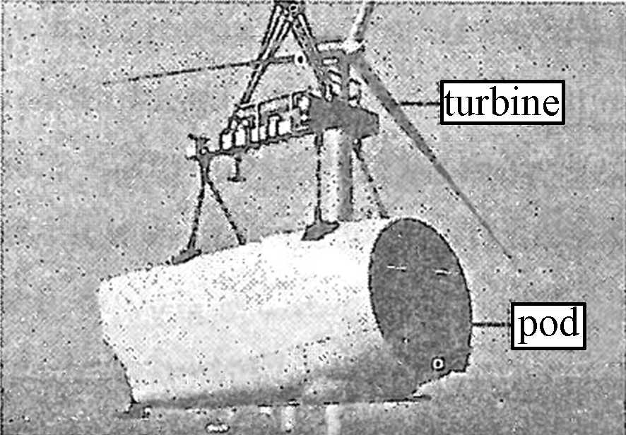Microsoft just finished a three－month experiment operating an underwater data center. A server rack(服务器支架) with the power of about 300 PCs was placed into a water－tight(防水) steel container and lowered into the ocean off the coast of central California.

The unusual experiment was launched because current data centers are unpleasantly inefficient. They're built where energy and land are cheap (not close to where people actually live). And they waste so much energy cooling their massive computers. The ocean can solve those problems. The cold ocean floor sufficiently cools the computing components inside the pod. And since most people live near the ocean, placing data centers under water could potentially increase the speed at which customers could access the information stored in Microsoft's cloud.

The experiment was so successful that Microsoft operated the underwater data center for 75 days longer than it had planned to. The next step is to get a larger pod, with about four times the computing power, under the ocean for testing. Unlike the first experiment, the next pod will also be equipped with turbines, which will transform the ocean's currents into electricity. It's not clear when, if ever, underwater data centers will become a possible product. “Our first experiment was like dipping our pinkie toe in the water, and now we're going for the big toe，” said Lee, corporate vice president of Microsoft Research.

Microsoft is still analyzing the environmental impacts of the study. Data centers are both hot and loud, which could have damaging effects on ocean life. Microsoft found that the noise its underwater data center produced was drowned out by nearby shrimp and crabs. The data centers are also built from recyclable materials, and Microsoft believes that the total carbon footprint of underwater data centers will be “dramatically lower” than current land－based centers.

Given the growth in the cloud, industry analysts believe that most of the world's data centers have yet to be built. But building a data center takes at least two years—an eternity in the fast－developing tech industry. As a result, Microsoft builds its data centers with the future in mind, installing far more computing power and space than it currently needs.

Lee believes that going under water can shift the building of data centers from construction projects to manufacturing jobs. “What if we could mass－produce these pods on an assembly line？” he thought. “We could deliver a data center, from conception to operation, in 90 days. That's dramatically different than what's happening today.”

9. What is the advantage of an underwater data center?

A. It can be lowered to the ocean floor easily.

B. It can cool computing components automatically.

C. It can be built close to the place where people live.

D. It can make information easily accessible to people.

10. We can infer that the underwater data centers ______．

A. cause little harm to the ocean life B. are more environmentally friendly

C. change the course of ocean currents D. are easy to build in large quantities

11. The underlined word “eternity” in Paragraph 5 means “______”．

A. an extremely long time B. an extended period

C. a seemingly short time D. a fruitful period

12. The passage tries to inform readers that ______．

A. an experiment was made in operating a data center

B. Microsoft will mass－produce pods on an assemble line

C. Microsoft succeeded in putting a data center underwater

D. underwater data centers are more efficient than land－based ones

D

Medical drugs sometimes cause more damage than they cure. One solution to this problem is to put the drugs inside a capsule, protecting them from the body—and the body from them—until they can be released at just the right spot. There are lots of ways to trigger (引发) this release, including changing temperature, acidity, and so on. But triggers can come with their own risks—burns, for example. Now, researchers in California have designed what could be a harmless trigger to date: shining near-infrared light (NIR, 近红外线) on the drug in the capsule.

The idea of using light to liberate the drug in the capsule isn’t new. Researchers around the globe have developed polymers (聚合物) and other materials that begin to break down when they absorb either ultraviolet (UV, 紫外线) or visible light. But tissues also readily absorb UV and visible light, which means the drug release can be triggered only near the skin, where the light can reach the capsule. NIR light largely passes through tissues, so researchers have tried to use it as a trigger. But few compounds (化合物) absorb NIR well and go through chemical changes.

That changed last year when Adah Almutairi, a chemist at the University of California, San Diego, reported that she and her colleagues had designed a polymer that breaks down when it absorbs NIR light. Their polymer used a commercially available NIR-absorbing group called o-nitrobenzyl (ONB). When they catch the light, ONB groups fall off the polymer, leading to its breakdown. But ONB is only a so-so NIR absorber, and it could be poisonous to cells when it separates from the polymer.

So Almutairi and her colleagues reported creating a new material for capsules that’s even better. This one consists of a long chain of compounds called cresol groups linked in a polymer. Cresol contains reactive(易反应的) components that make it highly unstable in its polymeric form, a feature Almutairi and her colleagues use to their advantage. After polymerizing the cresols, they cap each reactive component with a light-absorbing compound called Bhc. When the Bhcs absorb NIR light, the reactive groups are exposed and break the long polymer into two short chains. Shining additional light continues this breakdown, potentially releasing any drugs in the capsule. What’s more, Almutairi says, Bhc is 10 times better at absorbing NIR than is ONB and is not poisonous to cells.

13. According to the passage, which of the following could be the best trigger?

A. Temperature change. B. UV light. C. Acidity change. D. NIR light.

14. Why is ONB unsatisfactory?

A. It breaks down when it absorbs NIR light.

B. It is not effective enough and could be poisonous.

C. It has not come onto the market up till now.

D. It falls off the polymer and triggers drug release.

15. Which word can be used to complete the following process of changes?

Drug is released.

Polymer breaks down.

Part of the cresol is ______.

Bhcs absorb NIR.

A. protected B. formed C. exposed D. combined

高三年级 英语寒假在线课堂

专题复习十三 任务型阅读

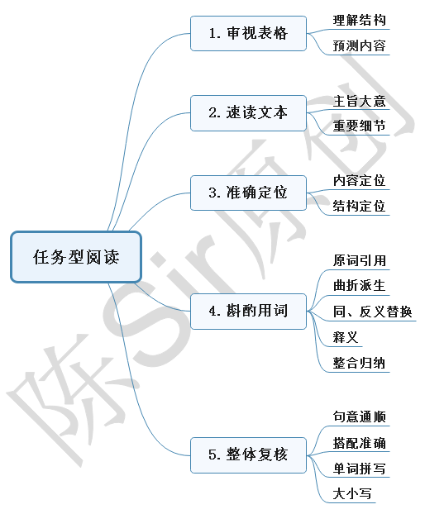**I. 填词专项训练**

1. Learners examine whatever information they think is relevant in order to construct a sense of what the task is about, what resources are available, and how they feel about the work to be done.

→Learners examine __________ information to further understand the task, available resources and their feeling about the work.

2. Blog is short for web log, an easily editable web space that is often compared to a shared digital diary or journal.

→Blog is short for web log, which can be easily edited to

__________ a digital diary or journal.

3. As a result, while parents might feel as though their teens are more self-centered than they were as teens, evidence doesn’t support that idea.

→There is no __________ in support of the idea that today’s teens are more self-centered than their parents were as teens.

4. Teachers should let students take an active part in finishing complex meaningful tasks.

→Let students participate __________ in complex meaningful tasks.

5. Attitude is a way that we think and feel about someone, or a way that we behave.

→Attitude is a feeling or opinion about someone, or our __________ towards others.

6. Finding the fight balance can be necessary for children’s enjoyment.

→Finding the fight balance is a __________ for children’s enjoyment.

7. Innovation will become the most irreplaceable driving force for the restructuring of the Chinese economy.

→Innovation will play a role that can be ________ by nothing in the restructuring of the Chinese economy.

8. They’re quite similar to each other in many ways and more cooperation wouldn’t bring about as much potential ability as between, say, public and private…

→The cooperation won’t have great effect because of their __________ in running universities.

9. Sure we need money and success, but having good relationships with friends and family are just as important.

→Know your personal needs. Money and success are needed, but having good relationships with others also __________.

10. For others, it can be a way to increase awareness about their products and services.

→ Others employ blogs to ___________ their products and services.

11. Every quality has extremes at both ends. The Golden Mean is the natural balance between these extremes.

→The Golden Mean __________ to natural balance between these extremes which exist at both ends of every quality.

12. Doing something to distract yourself is a good idea.

→Do something to take your __________ away from over-thinking.

13. Students are classified and put into different rooms based on their responses to housing form questions.

→Students are classified and _______ according to their response to housing form questions.

14. The landscape resembles famous Mount Huangshan.

→Its landscape is __________ to that of Mount Huangshan.

15. It stretches over an area of 120 sq km with more than 500 hills densely covered with various kinds of bamboo.

→It __________ an area of 120 sq km with various bamboos.

16. Research shows that the summer before college can be a dangerous time for teenagers.

→The summer before college throws __________ dangers to high-school graduates.

17.It‘s likely that your timing was just off. →__________ are that your timing was just off .

18. In many cases, they expect to receive special treatment and do not consider the feelings of others.

→Narcissists expect to be specially treated and usually have their own way, __________ of others’ feelings.

19. We must learn to guard against those feelings that have the possibility to lead our attitude down the wrong path and to strengthen those feelings that can lead us confidently into a better future.

→We should resist negative attitudes of others while __________ our positive ones.

20. LEDs use less energy than other forms of lighting. A typical LED bulb can produce around 83 lumens per watt—much more efficient than other lighting facilities.

→__________ with other forms of lighting, LEDs are much more efficient.

21. Although there is evidence that after-school programs can make a great difference, it is important to note that not all programs are equal.

→__________ a positive difference after-school programs make, we should note that not all programs are equal.

22. The books themselves will stop to be physical volumes and instead will be sources of interactive digital content that include text, videos and simulations.

→Books will be sources of interactive digital content with text, videos and simulations __________.

23. Infection through blood usually takes place if a person consumes infested meat, or even touches it.

→People __________ infested meat or touching it can get infected.

24. Services are a significant part of our exports, and make up about a quarter of our exported goods.

→A variety of products are provided around the world, services __________ for 25%.

25. The research could change thinking about the early history of world trade and provide insights into the mystery of just how and when Europe first realize the glorious culture at the other end of Eurasia.

→Help people find out more facts about Europe first __________ Chinese culture.

26. Each day he focuses on advancing himself. He spends long hours at the office, competes mercilessly with his coworkers, and flatters his superiors.

→The career-driven person is __________ to his office work, competing with his colleagues and flattering his superiors.

27. So you can find an activity, like knitting or working with your hands that requires so much attention that your brain is forced to be distracted from over-thinking.

→You can keep yourself __________ by doing some activity like knitting, which requires you to work with your motor skills and your thinking process.

28. He had always expressed his opinions when he thought laws and politics were wrong.

→He always __________ on laws and politics.

29. Instead of rushing to well-known sites only to be caught in long lines and huge crowds, you can explore some less-traveled places that have their own unique charms and scenery.

→ Some less-traveled scenic spots __________ touring for their attractive scenery.

30. Thus, one goal of teaching is to free students from the need for teachers, so they can continue to learn independently throughout their lives.

→One goal of teaching is to educate students to ________ on themselves for lifelong learning.

**II. 常见概括性词**

1. 介绍____________ 2. 定义____________3. 主题/话题__________4. 目的_____________

5. 重要性___________ 6. 问题____________7. 症状_____________8. 特点_____________

9. 原因_____________ 10. 结果__________11. 用途/功能_________12. 步骤____________

13. 过程____________ 14. 种类____________ 15. 态度___________16. 观点_____________

17. 建议____________ 18. 措施____________ 19. 总结/概括____________

20. 现象(单)_____________(复)____________ 21. 优/缺点_____________ _____________

22. 方法_____________ to do sth.; _____________ to doing sth.; _____________ to sth.

**III. 实战演练**

**Small Talk May Make Us Happier**

Small talk. Chitchat. These are the short conversations we have at parties, while we are waiting in line at the store, at family events or at work. Sometimes we make small talk with people we already know but not well. Often we have to make small talk with complete strangers. Many people find these small conversations about random topics difficult. Some people say they hate it. Others say small talk is a waste of time. They may even call it inactive chitchat or inactive chatter, meaning it doesn’t do anything. They consider small talk unimportant.

However, small talk is important.

These exchanges can open doors that may lead to larger, more meaningful conversations. When you first meet someone or talk to someone you don’t know well, it would be awkward to begin a conversation. However, small talk does help. Small talk also gives you the chance to decide if you want to get to know that person better – or not. Chitchat can also increase your feeling of understanding toward people you know but not well. Chatting with a colleague about their child may help you to understand more of their life outside the office. This could help build healthy work relationships. Small talk could even help our larger communities – our relationships with neighbors and colleagues.

However, some people are not good at small talk. Making small talk doesn’t have to be either awkward or boring. Here are some tips to improve your small-talking ability.

**Have some conversation starters ready.**

If you have seen a really good movie or have read a really good book, you can talk about that. You can talk about something that you recently learned. When you are sharing the same experience with someone, it’s easy to start a conversation. You simply notice and comment on what’s going on around you. For example, if you are at a party and a song comes on that you like or that reminds you of something, you can talk about that.

**Ask open-ended questions.**

These types of questions require more thought and more than a simple one-word answer. If you ask questions that need more details to answer, the conversation will go on longer. For example, if you are at a summer pool party, don’t ask a person if they like summer. Instead, ask them what they like or dislike about summer. So, instead of getting a one-word answer, you might have the chance to share in a memory.

**Become a student.**

Nobody knows everything. So, as someone is answering one of your open-ended questions, they bring up something about which you know nothing. So, tell them! This lets the other person become the teacher. They feel good about sharing their knowledge and you get to learn something. It’s a win-win situation.

**Don’t ask “So, what do you do?”**

Some people do not like their jobs. Or maybe they don’t want to talk about it. So, instead of asking, “What do you do for a living?” you may ask something like, “So, what have you been doing these days?” or “So, what have you been up to?” One general question can lead to an opportunity to share something you have in common. So, ask questions. Ask people about their families, their ambitions or even their fears. However, balance these questions with comments about yourself. Asking too many questions may make people feel they are in an interview rather than in a conversation.

Like anything else, getting good at making small talk takes practice. If you make small talk in your native language, you might become happier. If you make small talk in English, you will most definitely improve your speaking and listening skills.

|  |  |
| --- | --- |
| Outline | Supporting Details |
| Introduction | * Small talk or Chitchat is a short conversation we usually conduct on different 1.___________ with different people. * Small talk draws a mix of 2.___________ and criticism among public. |
| Significance  of small talk | Small talk is the foundation of spiritual communication which not only helps you break the 3.___________ when staying with strangers, but also helps establish a healthy relationship with them. |
| 4.___________ to improving small- talking ability | * Make 5.___________ for some conversation starters.   We’d better talk about things that we’re 6.___________ with, for similar experiences can make a conversation easier to start. |
| * Ask open-ended questions.   A general question will probably 7.___________ your conversations, while open-ended questions will make your conversations last longer. |
| * Become a student.   Be honest and modest in something new. A win-win situation will 8.___________ after mutual sharing and learning. |
| * Don’t ask “So, what do you do?”   Balance questions with comments about ourselves and 9.___________ talking about something people dislike. |
| Conclusion | * Practice makes perfect!   Small talk in native language can bring 10.___________ a sense of happiness, and small talk in English can improve your oral English. |

高三年级 英语寒假在线课堂

专题复习十四 读写任务（30字概括）

**Step 1. Lead-in**

A peacock was very unhappy with his ugly voice; and he spent most of his days complaining about it.   
 "It is true that you cannot sing;" said the fox, "but look how beautiful you are!"  
 "0h，but what good is all this beauty;" cried the bird, "with such an unpleasant voice!"  
 "Listen," said the fox, "each one owns something good: You have such beauty; the nightingale has his song; and the owl has his eyes. Even if you had a sweet voice, you would still complain about another thing. Why can't you just be happy about what you have already got?"

**Task: Read the following summaries and tell me why they are not perfect.**

**Example 1:** A peacock complains about his ugly voice all day without noticing his beautiful appearance. The bird which laugh at the peacock only catch his advantage. It is the fox that point out each one has their own advantages and stop complaining and just be happy about what you have now.

**Shortcomings:** _____________________________

**Example 2:** According to the passage, we can learn that everyone owns something good, we should not be unhappy for something we don’t own but we should thank for something we own and see our own beauty.

**Shortcomings:** ______________________________

**Example 3:** The article is mainly about a tale that when a peacock is complaining about his ugly voice, a bird who represents pessimistic people sigh while a fox who represents optimistic people reveals that we should value what we have rather than what we don't.

**Shortcomings:** ______________________________

**Example 4:** A peacock always complains about his ugly voice. Then the fox asks him to treasure his beauty because no one is perfect. We should just be happy about what we have already got.

**Shortcomings:** ______________________________

**Conclusion: A good summary of narration should**

1. cover all the key ____________ of the passage as a whole.

2. get the correct _____________ expressed by the passage, if any.

3. use proper ______________ but with limited words.

4. pay attention to sentence patterns, tense, voice and coherence.

**Step 2. Skills for a good summary of narration**

**1. Key information in a narration**

**Six elements**: _________ _________ _________ _________ ________ _______

When summarizing the information, we need to focus on **two key points**:

__________(main characters) do _________

**Practice:**

More than five years I was working at a little clinic after I graduated from college. Actually I didn’t like the job and felt depressed every day. One day while working at the cash register, an elderly couple came in with a little girl in a wheelchair.

As I looked closer at this girl, I realized that she was disabled. As I took the money from her grandparent, I looked down at the girl, who was giving me the cutest, largest smile I have ever seen. All of a sudden her handicap was gone and all I saw was this beautiful girl, and her smile, just like the warm sun in the winter melted me and almost instantly gave me a completely new sense of what life is all about.

It was her smile that took me from a poor, unhappy college student and brought me into her world; a world of smiles, love and warmth.

Now I’m a successful business person and whenever I get down and think about the troubles of the world, I think about that little girl and the remarkable lesson about life that she taught me.

|  |  |
| --- | --- |
| **Who (main characters)** | **what** |
|  |  |
|  |  |

**2.Implications given by the passage**

I should have a positive attitude to life.

**Skills:** to the ________; _________

**3. Language**

A student wrote a summary as follows:

The writer saw a little disabled girl. The girl smiled at him. She taught the writer to have a positive attitude to life and inspired him to become successful.

**Task:** **Combine it into ONE or TWO sentences.Try as many versions as possible .**

______________________________________________________________________________________________________________________________________________________________

**Skills:** ___________________________________________

**Step 3. Consolidation**

John was traveling by ship to Europe when a terrible storm came. A great leak was filling the ship with water. No matter how hard the sailors and passengers worked at the pumps, the water was still rising. The ship was sinking fast. There seemed to be no hope. But the captain told them not to give up hope. He said that there was hope so long as the ship remained above water. He promised that if they didn’t give up hope, he would land them safely. The captain’s powerful will moved them all. In the end he did land them safely.

After they landed, John found the captain to show his appreciation. But to his surprise, the captain said to him that he was the boy of 30 years ago who bought a geography book in his bookstore. John suddenly thought of the boy. At that time the boy didn’t have enough money, but he had gone from shop to shop and believed he could get what he wanted. Finally, he made it. Now , it was the same willpower of him that saved the lives of all the passengers.

**Task1: Underline the main characters and what they did, as well as the implications in the passage.**

**Task2: Write down the summary.**

____________________________________________________________________________________________________________________________________________________________________________________________________________________________________________________________________________________________________________________________

高三年级 英语寒假在线课堂

专题复习十五 读写任务（原因分析、观点表达）

**Step 1. Lead-in**

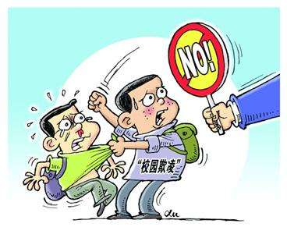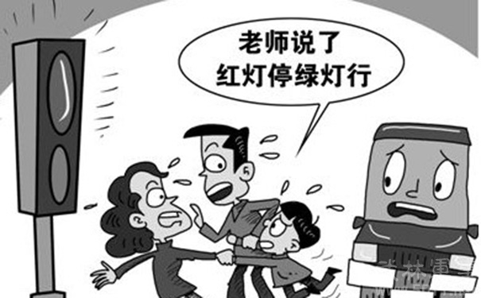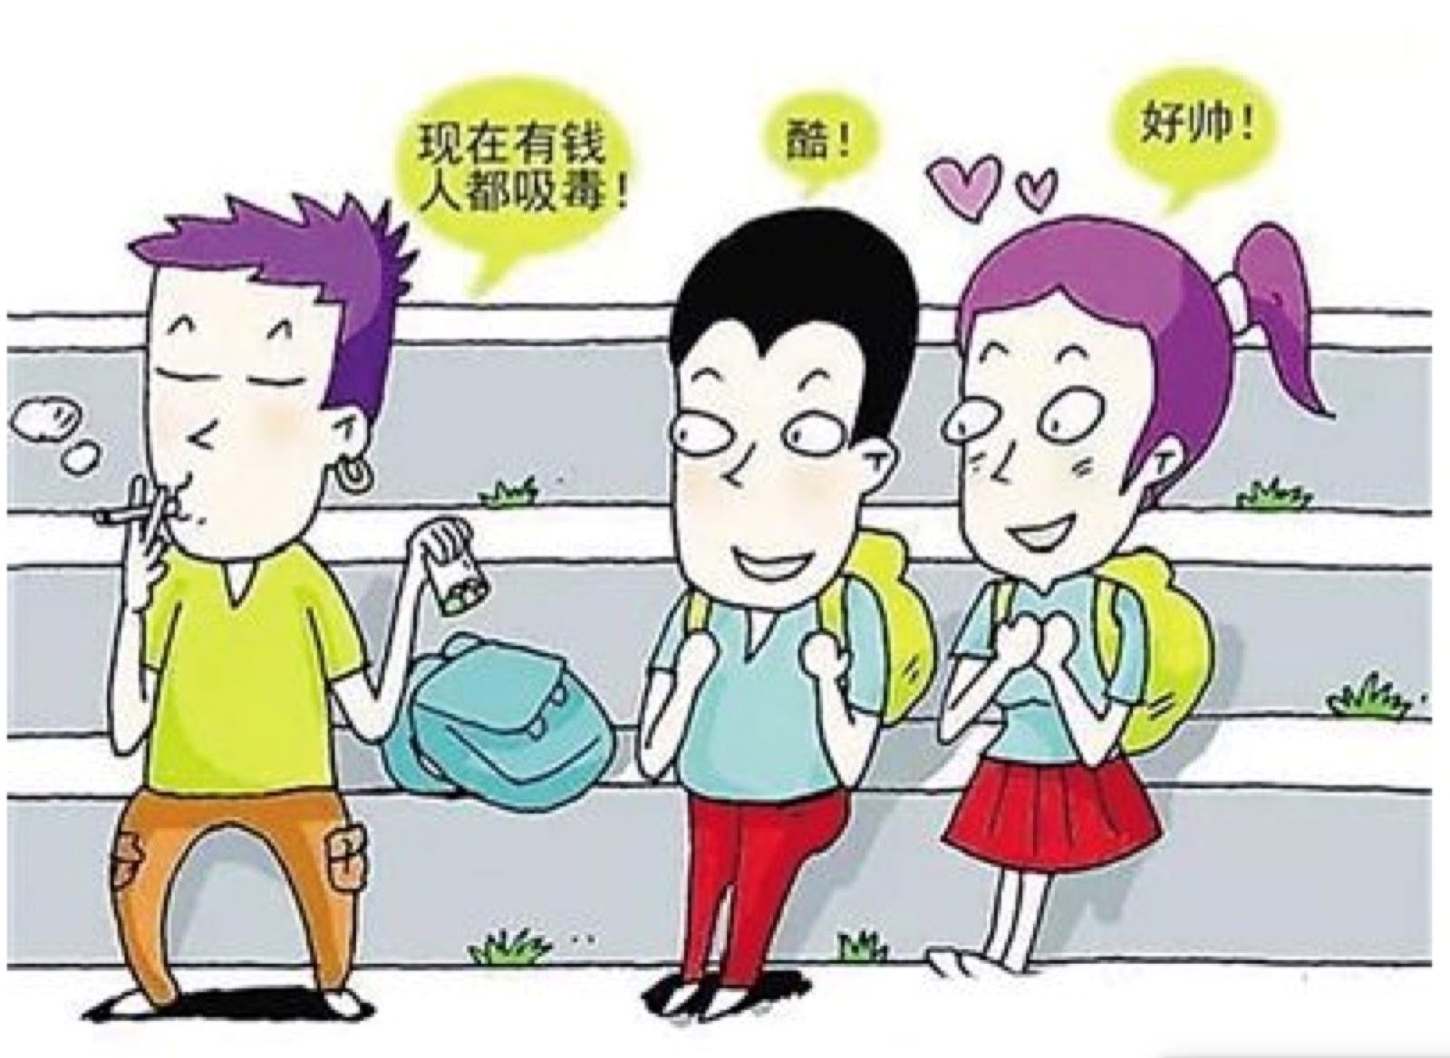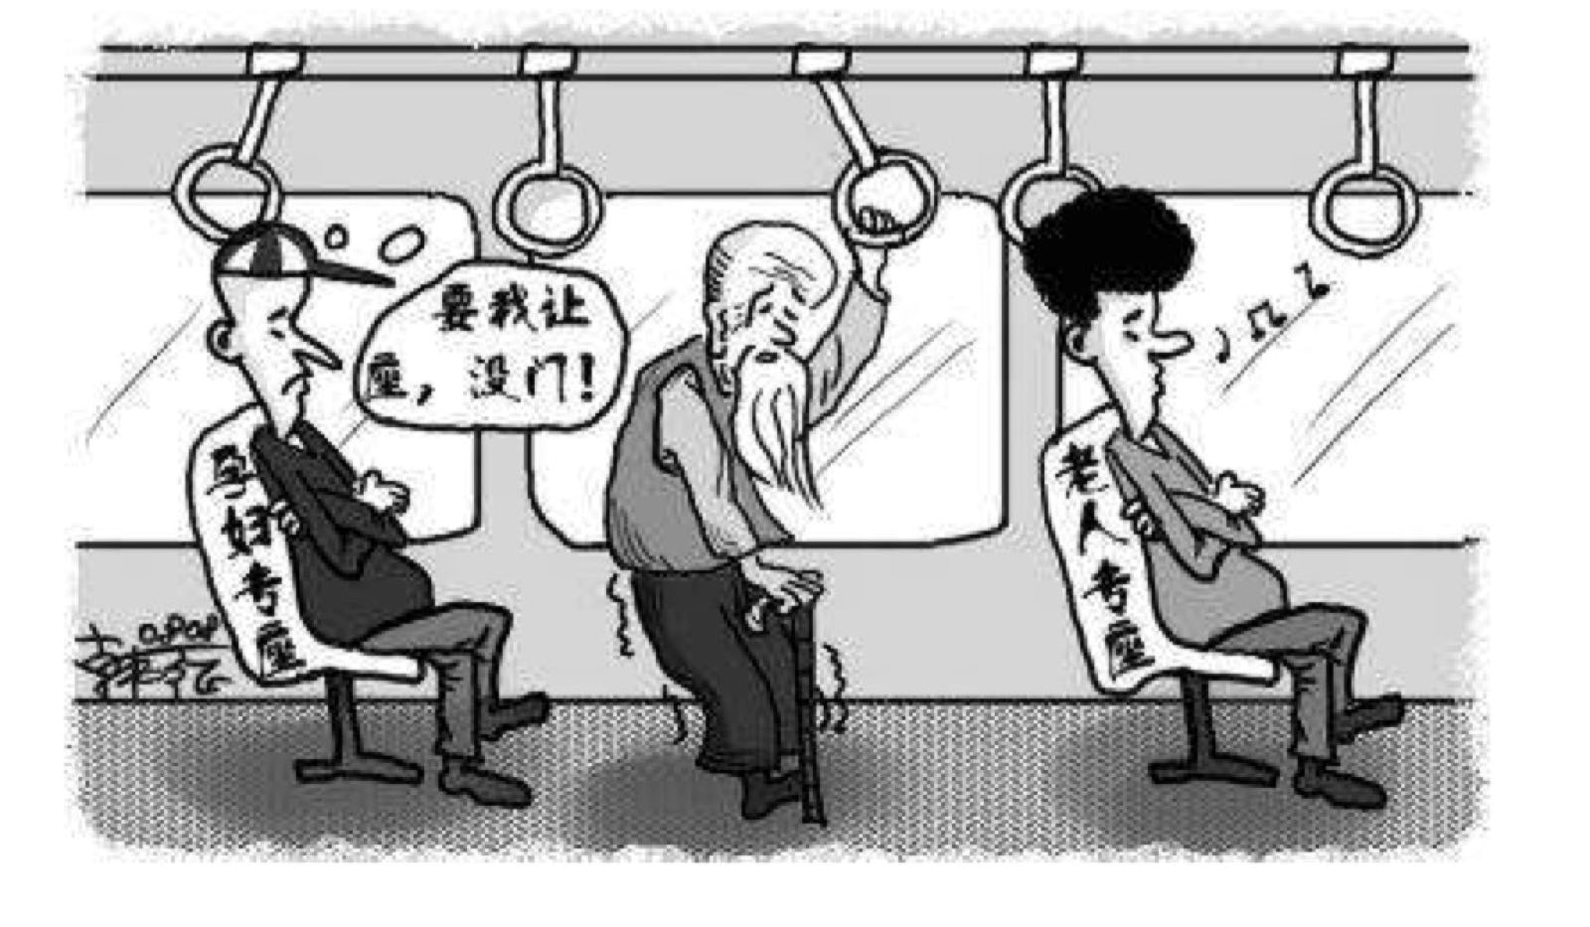

**What are the reasons hidden behind these social phenomena?**

**Different aspects to analyze the reasons: ____________________________________________**

**Step 2. How to write the body part**

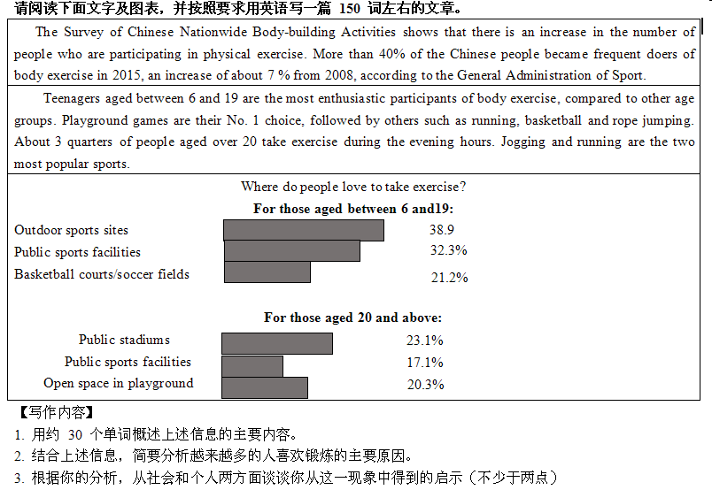

**Structure you should follow:** __________________________________________________

**Good examples of topic sentence:**

1. A number of factors __________ for/ __________ to this situation.
2. The reasons for this phenomenon are ____________.
3. There are some reasons ___________ to this phenomenon.
4. Why do more and more people take part in doing exercise nowadays?

**The outline of the main reasons:**

1. ________________________________

2._________________________________

3._________________________________

**Some useful conjunctions to connect different reasons:**

1. ________________________________

2._________________________________   
3._________________________________

**Some useful expressions:**

* 1. 锻炼 ____________________________________________________________________
* 2. 进行有规律的锻炼 ________________________________________________________
* 3. 强身健体 ________________________________________________________________
* 4. 降低发胖的风险 __________________________________________________________
* 5. 情绪高涨、低落 ___________________________________________________________
* 6. 感到放松和精力充沛 ______________________________________________________
* 7. 身心健康 ________________________________________________________________
* 8. 恢复精力 ________________________________________________________________
* 9.和……打交道 ____________________________________________________________
* 10.结识一些朋友 ____________________________________________________________

**Some good sentences for you to read for reference:**

1. To begin with, regular exercise promises to help people stay healthy and keep slim. This is why young adults are willing to go to gyms to keep in good shape.

2. Firstly, with the development of economy, the government has invested much money in improving infrastructure. So we have easier access to the fitness facilities.

3. In the first place, it is the need to keep healthy and get into shape that leads people to doing more exercise.

4. First of all, conventional wisdom has it that physical exercise can help us keep fit. If we work out regularly, we will be healthier. Instead, the lack of exercise may well cause illness. Our immune system will become weak and fail to fight against viruses.

5. Additionally, to some degree, exercise has become a fashion, which is promoted by many stars.

6. Furthermore, physical exercise can make us full of energy, which can lay a solid groundwork for our daily life and study.

7. And then, in a gesture to build up a strong body to fight against infection, many people feel obliged to do exercise.

8. At the same time, we are gradually aware of the importance of physical exercise with the government encouraging us to participate in exercise actively.

**Step 3. Practice**

Beijing police detained (拘留) 16 students from the Beijing Midi School of Music on suspicion of drug use, after a raid on a dormitory on November 24, 2015, following a statement that marijuana was being used at the school.

By June, 2015, there were more than 3 million known drug addicts in China, among whom there were more than 38,000 under the age of 18, according to an official at the drug control department of the Ministry of Justice.



**The Drug Danger Zone: Most Illegal Drug Use Starts in the Teenage Years**



写作内容：

1. 用约30个单词概述上述信息的主要内容；

**2. 结合上述信息，简要分析材料所反映的社会现象的原因及危害；**

3. 根据你的分析，谈谈你对解决此问题的看法或建议（不少于两点）。

_________________________________________________________________________________________________________________________________________________________________________________________________________________________________________________________________________________________________________________________________________________________________________________________________________________________________________________________________________________________________________________________________________________________________________

**Step 4. Summary**

Writing strategies of writing the body part:

1. following the structure of TS – SS – SS – SS (– CS)
2. finding inspiration from the given text, charts and even the required writing contents and listing the outline of supporting ideas
3. using conjunctive words to connect different supporting ideas
4. thinking twice before you begin to write and trying your best to employ some advanced expressions and structures

**Step 5. Homework**

You really should finish compiling that boring spreadsheet, but you just can’t bring yourself to do it. Maybe it can wait a little longer? Or it might just disappear if you ignore it long enough? You know the feeling.

According to Professor Piers Steel, of the Haskayne School of Business at the University of Calgary, 95% of people postpone important tasks at some point. But for some, procrastination (拖延症) isn’t occasional, but constant. Professor Joseph Ferrari, of DePaul University Chicago, found that 20% of the population of the world are habitual procrastinators. Sadly, delaying our duties isn’t very good for us. As the poet Edward Young wrote: “Procrastination is the thief of time.”

【写作内容】

1. 用约 30 个单词概述上述信息的主要内容；

**2. 结合上述信息，简要分析“拖延症”产生的原因及危害；**

3. 根据你的分析，就如何克服“拖延症”谈谈你的看法（不少于两点）。

_________________________________________________________________________________________________________________________________________________________________________________________________________________________________________________________________________________________________________________________________________________________________________________________________________________________________________________________________________________________________________________________________________________________________________